DEVELOPMENT OF A RISK-BASED GO-LIVE READINESS DECISION SUPPORT SYSTEM (DSS) FOR ENTERPRISE SOFTWARE DELIVERY

BY:
AKPO MAMUZOU RAPHAEL
2025/A/MIT/0214

DEPARTMENT OF INFORMATION TECHNOLOGY
SCHOOL OF COMPUTING
MIVA OPEN UNIVERSITY ABUJA,
NIGERIA.

A PROFESSIONAL MASTER’S PROJECT SUBMITTED TO THE DEPARTMENT OF INFORMATION TECHNOLOGY, SCHOOL OF COMPUTING, MIVA OPEN UNIVERSITY ABUJA, NIGERIA.

IN PARTIAL FULFILLMENT OF THE REQUIREMENTS FOR THE AWARD OF THE PROFESSIONAL MASTER OF INFORMATION TECHNOLOGY (MIT) DEGREE IN INFORMATION TECHNOLOGY
MAY, 2026

ABSTRACT

The complexity and rapid development cycles of enterprise software systems make Go-Live decisions difficult because all technical, operational, security, business, compliance, and support criteria must be addressed concurrently. Existing solutions offer helpful functionalities in terms of individual components of release management such as risk assessment, IT service management (ITSM), CI/CD gates, and auditing capabilities. Nevertheless, from the literature review, it becomes clear that existing functionalities are not sufficiently integrated into the per-release go-live process in relation to readiness assessment, stakeholders' governance, and tamper-evident record keeping. Thus, this project aimed to develop a risk-based Go-Live Readiness Decision Support System (GoLive DSS) for enterprise software delivery. The GoLive DSS was built using Design Science Research Methodology (DSRM). Decision model of the system utilizes likelihood × impact risk scoring at criterion level and then uses weighted multi-criteria aggregation across ten readiness domains. Critical release gates may supersede the readiness aggregate score, while deterministic Deployment Risk Index (DRI) considers readiness score deficit, gates blockers, weak readiness domains, and variability of evaluators' scores to provide an interpretable indication of release risk. The SHA-256 hash-based chain of approvals gives a tamper-evident record of governance, whereas detection of any post sign-off modifications gives details about the changed assessments. Representative system walkthrough evaluations of the assessment process showed that the process integrated assessment, evidence management, risk scoring, gate evaluations, governance voting, cryptographic authentication, modification detection, dashboarding, and auditing effectively. In contrast to current methods that address various facets of release management and risk control in a partial way, the clear innovation lies in the integration of these techniques in one decision support procedure for each release. The results demonstrate technical feasibility and transparent decision support, while formal testing and empirical validation of the DRI remain future work.

TABLE OF CONTENTS

CHAPTER ONE 10
INTRODUCTION 10
1.1 Background to the Project 10
1.2 Statement of the Problem 12
1.3 Aim and Objectives of the Project 14
1.4 Scope of the Project 14
1.4.1 Exclusions 15
1.5 Significance of the Project 15
1.6 Operational Definition of Key Terms 16
CHAPTER TWO 18
LITERATURE REVIEW AND TECHNOLOGY CONTEXT 18
2.1 Review of Existing Systems and Commercial Solutions 18
2.1.1 Manual and Spreadsheet-Based Release Checklists 18
2.1.2 ITSM Change-Management Platforms 19
2.1.3 CI/CD Deployment Gates 19
2.1.4 Release Engineering and SRE Practices 20
2.1.5 Blockchain-Augmented DevSecOps 20
2.1.6 Critical Assessment of Existing Systems 20
2.2 Review of Relevant Technologies, Tools, and Frameworks 22
2.2.1 Next.js and the Application Architecture 22
2.2.2 Supabase, PostgreSQL, and Row-Level Security 22
2.2.3 Web Crypto API and SHA-256 Hashing 23
2.2.4 Data Visualisation 24
2.2.5 NIST Secure Software Development Framework 24
2.2.6 Logging and Audit-Record Management 24
2.3 Synthesis and Gap Analysis 25
CHAPTER THREE 28
SYSTEM DESIGN AND METHODOLOGY 28
3.1 Research Approach and Design Methodology 28
3.2 System Analysis 30
3.2.1 Stakeholder and Role Analysis 30
3.3 System Architecture 33
3.3.1 High-Level Architecture 34
3.4 Database Design 35
3.4.1 Entity Overview 35
3.5 Decision Model Design 37
3.5.1 Criterion-Level Risk 37
3.5.2 Weighted Domain Scoring 38
3.5.3 Deterministic Deployment Risk Index 38
3.5.4 Gate Rule Logic 39
3.6 Governance Workflow Design 39
3.7 Cryptographic Audit Ledger Design 40
3.8 Post-Sign-Off Modification Detection 40
3.9 User Interface Design 41
3.10 Security Design 42
3.11 Ethical Considerations 42
3.12 Evaluation Methodology 43
CHAPTER FOUR
SYSTEM IMPLEMENTATION 44
4.1 Introduction 44
4.2 Development Environment and Application Structure 45
4.2.1 TypeScript Configuration 46
4.3 Application Authentication and User Access 46
4.4 Implementation of the Assessment Wizard 47
4.5 Evidence Management 48
4.6 Criterion-Level Comment Threads 49
4.7 Unsaved-Change Protection 50
4.8 Implementation of the Scoring Engine 51
4.9 Implementation of Gate-Rule Processing 53
4.9.1 Gate Rule Blocker Override Principle 54
4.10 Implementation of the Deployment Risk Index 55
4.11 Deterministic Mitigation Mapping 58
4.12 Implementation of the Governance Workflow 58
4.13 Implementation of Conditional Go 60
4.14 Implementation of the Cryptographic Audit Ledger 61
4.15 Cryptographic Verification 63
4.16 Proof Certificate 64
4.17 Post-Sign-Off Modification Detection 65
4.18 Database Implementation 66
4.19 Row-Level Security Implementation 67
4.20 Role-Based Access Control Implementation 69
4.21 Executive Dashboard Implementation 69
4.22 Governance Board Implementation 70
4.23 Data Visualisation 71
4.24 Printable Audit Reporting 71
4.25 Implementation of Security Controls 72
4.26 Implementation of Audit Logging 73
4.27 Integration of the Implemented Components 73
4.28 Relationship Between the Implementation and Chapter Three Requirements 74
4.29 Performance and Scalability Considerations 75
CHAPTER FIVE 77
DEMONSTRATION, RESULTS AND EVALUATION 77
5.1 Introduction 77
5.2 Evaluation Approach 78
5.3 Demonstration of Core Scenarios 79
5.3.1 Authentication and Role-Based Access 79
5.3.2 Assessment Wizard and Criterion-Level Risk Calculation 80
5.4 Evaluation Against Project Objectives 85
5.4.1 Evidence of Achievement 87
5.5 Discussion of Results 88
5.6 Limitations of the Evaluation Approach 89
CHAPTER SIX 90
SUMMARY, CONCLUSION AND RECOMMENDATIONS 90
6.1 Introduction 90
6.2 Summary of the Project 91
6.3 Conclusion 93
6.4 Professional Contributions 93
6.4.1 Contribution to Software Release Governance 93
6.4.2 Contribution to IT Decision Support 94
6.4.3 Contribution to Auditability 94
6.4.4 Contribution to Professional IT Practice 94
6.5 Limitations of the Project 94
6.6 Recommendations for Future Enhancement 95
6.6.1 Integration with CI/CD Platforms 95
6.6.2 Integration with IT Service Management Platforms 95
6.6.3 Historical DRI Validation 95
6.6.4 Advanced Decision Models 96
6.6.5 Enhanced Evidence Verification 96
6.6.6 Enterprise Identity Integration 96
6.6.7 Notification and Escalation 96
6.6.8 Mobile and Responsive Enhancements 97
6.6.9 Formal Test Suite Execution and Empirical Validation 97
REFERENCES 98

LIST OF FIGURES
Figure 3.1 | Layered System Architecture of GOLive DSS
Figure 3.2 | Simplified Entity Relationship Diagram
Figure 3.3 | Executive Dashboard (Wireframe)
Figure 4.1 | User Authentication Interface
Figure 4.2 | Assessment Wizard
Figure 4.3 | Evidence Management Interface
Figure 4.4 | Scoring and Gate-Rule Processing
Figure 4.5 | Governance Workflow
Figure 4.6 | Cryptographic Verification Process
Figure 4.7 | Post-Sign-Off Modification Detection Workflow
Figure 4.8 | GoLive DSS Entity Relationship Diagram
Figure 4.9 | Executive Dashboard
Figure 4.10 | Governance Board
Figure 4.11 | Printable Audit Reporting
Figure 5.1 | Authentication and Role Based Access
Figure 5.2 | BBusiness & Product Alignment Domain
Figure 5.3 | Change Management domain
Figure 5.4 | Service Desk & Support domain
Figure 5.5 | Executive Dashboard

LIST OF TABLE
Table 2.1 | Literature-Based Gap Analysis and System Positioning
Table 3.1 | DSRM Activities Mapped to the Project
Table 3.2 | Stakeholder Roles and Responsibilities
Table 3.3 | Database Tables and Purpose
Table 5.1 | Evaluated Criteria and Supporting Evidence
Table 5.2 | Evaluation of Project Objectives

CHAPTER ONE

INTRODUCTION

1.1 Background to the Project
The emergence of DevOps and continuous delivery has transformed the way software organizations create and deliver their products. Continuous delivery is all about keeping the software ready for release and releasing it whenever the occasion calls for it, whereas continuous deployment takes this approach a step further through automatic deployments once the necessary controls have been passed (DORA, 2024). Likewise, the research on software delivery performance has shown that software delivery performance can be measured by a number of indicators, namely: deployment, frequency, change lead time, percentage of changes failing, and failure recovery time from deployments (Forsgren et al., 2018; DORA, 2024). These advancements suggest that software delivery is becoming a rapid process in which software organizations need to find a good compromise between delivery speed and reliability.
Nonetheless, increasing the release speed does not mean the absence of release governance. The research by DORA reveals that continuous delivery is intended to minimize software delivery risks, provided companies possess the necessary engineering capabilities to guarantee reliable results. Increasing the deployment rate without modifying foundational engineering practices drastically increases the chance of software delivery failure and systemic instability. Empirical data from the State of DevOps 2024 Report by DORA (2024) underlines the severity of this issue, demonstrating that low-performing organizations suffer from a Change Failure Rate (CFR) as high as 45% to 60%. This means approximately half of all code deployments result in critical production incidents, service degradations, or immediate rollbacks. Consequently, forcing organizations to allocate up to 80% of operational budgets toward post-release remediation. Thus, making informed decisions regarding the readiness of a specific software release is highly critical from a risk management and cost-stabilization perspective.
It is possible to state that software release decisions often contain significant uncertainty as the decision makers take into account several aspects connected with the quality, reliability, security, stakeholders' demands, costs, and possible adverse effects of failure. In their research, Soyer et al. (2025) investigates the problem of software release and provides the decision support framework that allows defining the optimal time for releasing the product. In his earlier research, Denzinger and Ruhe (2004) describes the decision support methods for solving the software release planning problem under uncertainty and conflicting preferences of stakeholders. These studies support the view that software release decisions are not necessarily simple binary technical decisions but can be treated as structured decision problems involving multiple criteria and competing considerations.
Decision Support Systems (DSS) offer an effective computational framework for managing such semi-structured problems by synthesizing heterogeneous data, executing explicit decision logic, and delivering actionable analytics to support final human judgment. Within software engineering, the utility of the DSS approach is demonstrated by research frameworks such as Aslam et al. (2017), who codified historical software risk knowledge into a rule-based engine for early-stage project planning. Similarly, quality assessment models (SQALE) and industry static analysis tools (SonarQube) evaluate technical debt, code complexity, and security vulnerabilities. Additionally, modern Continuous Integration/Continuous Deployment (CI/CD) pipelines enforce basic automated quality gates based on unit and integration test pass rates. However, existing computational approaches primarily address early-stage planning risks or isolated, single-dimension code metrics. Consequently, there remains a critical gap in empirical literature regarding automated, holistic decision support frameworks explicitly designed for real-time go-live release readiness at the final deployment gate.
It is very important to bridge the gap; otherwise, without solving the issue, organizations will remain extremely exposed to the problems that cost up to 80% of the budgets to resolve after the release goes live. Moreover, the readiness of the software to be released cannot be established based on only one of the qualities. The release might meet all of its functional requirements, but there could be any number of risks related to security, operations, infrastructure, data, regulation, compliance, and support of services. Multi-criteria decision-making offers an approach to evaluate decisions based on multiple criteria and weights or preferences (Hwang & Yoon, 1981). With respect to risk management applications, it is possible to represent and weigh different aspects of risk rather than assume all the factors are equally significant. Taking the approach into consideration, the present research proposes to establish go-live readiness with respect to multiple weighted criteria and to assess each criterion separately in terms of likelihood and impact. The resulting approach is intended to provide a more structured basis for release-level governance by combining quantified readiness assessment with critical decision gates and supporting governance mechanisms.

1.2 Statement of the Problem
In addition to the growing complexity of enterprise software releases, organizations must make go-live decisions based on a variety of technical, operational, security, business, and compliance factors. Yet, in practice, software release decisions can be uncertain and complex because of competing stakeholder demands. As a result, software release planning and timing have been identified by researchers as a decision support problem, not a technical one (Denzinger & Ruhe, 2004; Soyer et al., 2025). Researchers have proven the benefits of applying structured decision support in the area of software risk assessment, and software delivery researchers have identified measurable metrics such as change failure rate and deployment rework rate to evaluate the results of software releases (Aslam et al., 2017; Forsgren et al., 2018; DORA, 2024). Despite these advances, there is still a need for a consolidated approach to go-live governance involving quantified release readiness evaluation, critical release gates, verifiable records of approvals, tracking of changes made after the approval process and decision support based on risks. This study aims at solving the problem of lack of structure in go-live governance using a web-based, risk-based Decision Support System. The four measurable gaps are:
- Subjective and unquantifiable go-live decisions: The release of software products is dependent on a number of different criteria, uncertainties and stakeholders' preferences. Decision support becomes useful in order to provide consistency in risk assessment and release plans (Denzinger & Ruhe, 2004; Aslam et al., 2017; Soyer et al., 2025). However, the scientific literature examined in relation to this project cannot identify any single process of go-live governance that incorporates multi-domain weighted scoring and explicitly defined critical release gates. This problem is solved in the proposed system because the scores generated by the evaluators will be weighted, while certain gate-rule criteria will override them in case of critical release condition failure.
- Lack of cryptographic verifiability of governance records: Software governance produces various records about assessments, evidence, approvals and decisions. Cryptographic log research showed that records could be tampered with and that it is possible to detect tampering (Schneier & Kelsey, 1999). However, there is not enough information concerning the application of this concept to the multi-domain software go-live approval process in the examined literature. The problem is solved with the use of SHA-256 hash-chained approval ledger that allows for verification of integrity of the governance decisions made.
- Limited ability to detect post-go-live changes in assessment data: The choice of go-live date is done on the basis of the information obtained during the assessment process. If some of the assessment responses, evidence or risk ratings have been changed after making the initial approval, then the original assessment result will no longer be applicable. The sources reviewed during the course of this study provide theoretical proof of structured software risk assessment and measurement of deliverable outcomes (Aslam et al., 2017; DORA, 2024). Yet, there is no method described that would enable automatic detection of any changes after formal sign-off. Thus, this study contributes to the field through development of a change detection and notification mechanism for decision-makers to consider re-voting.
- Limited support for individual release decisions: Studies related to software delivery prove that there are ways of measuring deployment outcomes using such metrics as change failure rate and deployment rework rate (Forsgren et al., 2018; DORA, 2024). The research on decision support systems in the area of software releases shows that the timing of a particular release can be viewed as a risk analysis problem (Soyer et al., 2025). However, these studies fail to provide a per-release governance model proposed in the course of this project. Specifically, assessment weaknesses are translated into an actionable measure of the release risk and the conditions of mitigation. The Deployment Risk Index proposed in the paper is a deterministic model based on assessment data, gating conditions, domain weaknesses, and rating variance.

1.3 Aim and Objectives of the Project
Aim: To design and develop a risk-based Go-Live Readiness Decision Support System for enterprise software delivery.
Objectives:
- To design a web-based risk-based Go-Live Readiness Decision Support System that integrates multi-domain readiness assessment, weighted risk scoring, critical gate rules, evidence management, and role-based governance workflows.
- To develop the proposed system with cryptographically verifiable approval records, post-sign-off modification detection, and a deterministic Deployment Risk Index for supporting release-risk assessment and mitigation.
- To evaluate the developed system based on its ability to support structured go-live assessment, enforce critical release conditions, maintain auditable approval records, detect post-sign-off changes, and provide interpretable risk information for release decision-making.

1.4 Scope of the Project
The current project revolves around the design, development, and evaluation of a web-based risk-based go-live readiness decision support system used in the delivery of enterprise software.
There are ten readiness domains that make up the system: Business & Product Alignment, Change Management, Code Quality & Testing, Data & Analytics, Deployment & Operations, Infrastructure & Performance, Legal & Regulatory, Monitoring & Observability, Security & Compliance, and Service Desk & Support.
The system will offer weighted readiness assessment, criterion-level likelihood and impact rating, evidence entry, comments, gate rule enforcement, role-based assessment and approval, recording of release decision, logging of audit data, cryptographic integrity verification of approval records , sign off alteration detection, and deployment risk index.
The final go-live release recommendation will take the form of either Go, Conditional Go, or No-Go decision. Conditional Go decision will be accompanied by the mitigation conditions, owner of such conditions and deadline to complete the conditions. Gate rules failure will have the ability to override the overall readiness score and stop the go live decision from being made.
This project focuses on decision support and governance. This system does not automate software deployment to the production and neither does it take the place of professional judgement of release managers, technical leads, security, business and executive decision makers.

1.4.1 Exclusions
The system does not encompass any automated deployment capability, design of a new predictive model using machine learning for forecasting software outages, substitution of the existing enterprise DevOps solutions, and certification of compliance with relevant standards or legal requirements.
The cryptographic ledger is incorporated to provide tamper evidence for governance records; it is not intended to represent a full blockchain solution or a substitute for corporate security controls.
The Deployment Risk Index is a deterministic tool created specifically for the purposes of this project and cannot be seen as any kind of statistical measure of the risk of production failure until proved otherwise.
Such limitations were deliberately chosen in order to make sure that the project is technically feasible and its claims are verifiable.

1.5 Significance of the Project
The relevance of the project is mainly due to the contribution that the project will make in relation to software engineering, risk management, and the governance of enterprise software releases.
- To Enterprise Software Companies: The system offers a standardized way of gathering release-readiness data from various functions. With the help of criteria that are weighted and gate rules that are clearly defined, the system can provide a consistent indication of release readiness for decision makers rather than depending solely on subjective assessment.
- To Project Managers and Release Decision Makers: The system offers a single governance process for review of the assessment results, the evidence gathered, the risks that have been identified, the approval decision, and the mitigation conditions prior to making the release decision. The Deployment Risk Index is an added tool for understanding the risk conditions identified.
- For Auditors and Compliance Officers: The cryptographic validation log presents a new way to verify the integrity of governance information. Research on secure audit logs has shown the utility of cryptographic methods in detecting any tampering with historical records (Schneier & Kelsey, 1999). In the proposal, this is applied particularly to records of software release approval decisions.
- For Software Development Practice: This project illustrates how decision support principles can be employed in the field of software release governance. Decision-support principles have already been demonstrated to work well in software risk assessment (Aslam et al., 2017), and software release literature has viewed release planning and timing as a decision problem (Denzinger & Ruhe, 2004; Soyer et al., 2025).
- Future Researchers: The project opens up opportunities for research in quantitative go-live readiness evaluation, release risk prediction models, cryptographically verifiable governance processes, and automated post-approval detection of release risk changes The deterministic risk model can also provide a baseline against which future statistical or machine-learning approaches can be evaluated.

1.6 Operational Definition of Key Terms
Go-Live: The formal transition of a software release from its pre-production environment into operational production use.
Go-Live Readiness: The extent to which a software release satisfies defined technical, operational, business, security, compliance, and support requirements before production deployment.
Decision Support System (DSS): An information system that provides data, analytical models, and structured information to support human decision-making in situations involving multiple factors or uncertainty.
Gate Rule: A mandatory release condition whose failure can prevent a release from receiving a Go recommendation regardless of its aggregate readiness score.
Deployment Risk Index (DRI): The deterministic risk indicator developed in this study to summarize selected risk conditions identified during the go-live assessment.
Post-Sign-Off Modification: A change made to an assessment response, evidence item, criterion score, or other relevant release information after a formal approval decision has been recorded.
Cryptographic Audit Ledger: A sequence of governance records linked through cryptographic hashes so that unauthorized modification of a previous record can be detected.
Conditional Go: A release decision indicating that deployment may proceed subject to specified mitigation conditions, responsible ownership, and deadlines.

CHAPTER TWO

LITERATURE REVIEW AND TECHNOLOGY CONTEXT
In this chapter, the GoLive Decision Support System (GoLive DSS) is contextualised in relation to current literature and practice in software risk assessment, decision support, change and release management, continuous delivery, software delivery performance, secure audit logging, and data governance. The review is not limited to considering go-live as a technical deployment problem. On the contrary, it treats go-live as a multifaceted organisational decision, where such factors as technical readiness, operational readiness, business requirements, security, compliance, and judgement need to be considered together. This chapter is structured into three parts. Part 2.1 analyses the existing systems and commercial solutions in change, release, and deployment governance. Part 2.2 discusses the technology and frameworks in the context of the development of GoLive DSS. Part 2.3 draws on the reviewed literature to identify the specific research and technological gap that the research project addresses.

2.1 Review of Existing Systems and Commercial Solutions

2.1.1 Manual and Spreadsheet-Based Release Checklists
Manual release checklists remain a practical mechanism for organising go-live activities because they are inexpensive, flexible, and easy to customize. However, the literature on software risk management indicates that risk assessment is frequently fragmented and insufficiently integrated across the software lifecycle (Masso et al., 2020).
The principal weakness of a spreadsheet-based checklist is therefore not that it cannot contain the required information. It can. The problem is that the spreadsheet does not inherently guarantee consistent scoring, controlled approval, immutable historical evidence, or automated detection of post-approval changes. These properties must instead be created through organisational procedures.
A spreadsheet can consequently function as a checklist but is weaker as a governance system. GoLive DSS addresses this distinction by treating the checklist as structured decision data rather than as a static document.

2.1.2 ITSM Change-Management Platforms
Modern ITSM platforms provide more sophisticated change-management capabilities. ServiceNow (2024), for example, provides configurable risk assessments in which questions can be defined and weighted scores can be used to calculate the risk associated with a change request (ServiceNow, 2024).
This is an important finding because it demonstrates that weighted change-risk assessment is not merely an academic concept. It already exists in enterprise ITSM practice. Consequently, the novelty of GoLive DSS cannot reasonably be claimed to be the mere use of weighted risk questions.
The more specific gap lies in the integration of multiple governance capabilities. The proposed system combines multi-domain readiness scoring with hard blockers, stakeholder voting, cryptographically verifiable approval records, post-sign-off change detection, and a release-level risk indicator. The contribution is therefore architectural and integrative rather than simply the invention of weighted risk scoring.

2.1.3 CI/CD Deployment Gates
CI/CD systems provide another established approach. Jenkins (2024), for example, supports pipeline input steps that can explicitly request human approval before the pipeline proceeds or is aborted (Jenkins Project, 2024). Continuous integration and continuous deployment research similarly identifies automated testing, build verification, security checks, and deployment controls as central elements of modern delivery pipelines (Shahin et al., 2017).
The limitation is scope. A deployment gate generally evaluates conditions that can be directly expressed within the technical pipeline. A business owner may need to confirm customer communication, a finance representative may need to confirm billing changes, an operations representative may need to confirm support readiness, and a compliance representative may need to confirm regulatory requirements. These are not necessarily pipeline events.
GoLive DSS therefore complements rather than replaces CI/CD gates. Technical pipeline results can form evidence for the GoLive assessment, while the DSS provides a broader governance layer around the final release decision.

2.1.4 Release Engineering and SRE Practices
Google's release-engineering guidance emphasises reproducible builds, controlled release processes, and intentional changes to the release process (McNutt, 2016). This approach is particularly strong in environments where software is deployed frequently and reliability is critical.
Nevertheless, release engineering focuses primarily on making software delivery reliable. GoLive DSS addresses the additional question of whether the organisation should accept the residual risk associated with a particular release. These are complementary objectives rather than competing ones.

2.1.5 Blockchain-Augmented DevSecOps
Nallam's (2025) blockchain-enabled DevSecOps pipeline provides an emerging example of using decentralised infrastructure to improve auditability of software-delivery events (Nallam, 2025). Its importance lies in demonstrating that release activity can be represented as verifiable digital evidence rather than as ordinary mutable logs.
Its limitations, however, are significant from the perspective of GoLive DSS. The prototype focuses on CI/CD event recording and does not constitute a multi-domain release-readiness DSS. The system therefore addresses audit integrity but not the complete decision problem.

2.1.6 Critical Assessment of Existing Systems
The literature indicates that existing approaches each solve a different part of the go-live problem:
Existing Approach | Principal Strength | Principal Limitation Relative to GoLive DSS
Spreadsheet/Checklist | Flexible and inexpensive | Weak automation, scoring consistency, and tamper-evidence
ITSM/Change Management | Workflow, risk assessment and approvals | Primarily centred on change records and workflow rather than an integrated release-readiness model
CI/CD Gates | Strong technical automation | Primarily technical; limited representation of business and organisational readiness
Release Engineering | Reproducible and reliable delivery | Focuses on delivery reliability rather than governance decision quality
Blockchain Audit Prototype | Tamper-evident release records | Logging rather than multi-domain decision support
GoLive DSS | Combines scoring, gates, voting, audit evidence and risk forecasting | Requires empirical validation to establish whether the integrated model improves decision quality
The key synthesis is therefore that the literature does not demonstrate a complete absence of release-governance systems. Rather, it reveals fragmentation. Different technologies provide technical gates, risk assessment, approval workflows, performance measurement, and audit logging, but these capabilities are generally distributed across separate tools.
This distinction is central to the justification of GoLive DSS.

2.2 Review of Relevant Technologies, Tools, and Frameworks

2.2.1 Next.js and the Application Architecture
GoLive DSS is implemented as a web-based system using Next.js and TypeScript. Next.js's App Router provides file-system-based routing and supports React Server Components, Server Functions, layouts, streaming, and related application features (Vercel, 2024).
The framework is suitable for the project because the DSS combines interactive assessment forms with dashboards, authentication-sensitive views, database interactions, and server-side operations. Current Next.js documentation also identifies server rendering, prefetching, streaming, and client-side transitions as mechanisms for improving application navigation (Vercel, 2024).
The use of TypeScript further provides static type checking. The TypeScript strict option enables a family of stronger type-checking behaviours, including strict null checking and other checks designed to identify potential programming errors earlier in development (Microsoft, 2024).
Critically, these technologies do not themselves establish system correctness. Type safety and framework-level safeguards can reduce classes of implementation errors, but they cannot guarantee that the GoLive scoring model, authorisation logic, or governance rules are conceptually correct. These must be validated separately.

2.2.2 Supabase, PostgreSQL, and Row-Level Security
Supabase provides PostgreSQL-based persistence and authentication infrastructure for the system. A major technical feature relevant to GoLive DSS is PostgreSQL Row-Level Security (RLS). PostgreSQL allows row-security policies to control which rows a user or role can retrieve, insert, update, or delete. When RLS is enabled without an applicable policy, PostgreSQL adopts a default-deny behaviour for normal access (PostgreSQL Global Development Group, 2024).
Supabase similarly recommends enabling RLS on exposed tables and using policies to control access according to authenticated user identity and application requirements (Supabase, 2024). This is relevant to GoLive DSS because assessment records may contain information that should only be visible to authorised project participants. Database-level access control provides an additional security layer beyond application-level checks.
However, RLS should not be presented as a complete security solution. Supabase explicitly notes that service-role keys bypass RLS and therefore must not be exposed in client-side applications (Supabase, 2024). The architecture must consequently ensure that privileged credentials remain server-side.

2.2.3 Web Crypto API and SHA-256 Hashing
The GoLive DSS audit mechanism uses the browser's Web Crypto API to generate SHA-256 hashes. The SubtleCrypto.digest() method supports SHA-256 and returns a fixed-length cryptographic digest of supplied data (MDN Web Docs, 2024).
This capability makes it possible to implement a lightweight hash-chain mechanism without introducing a blockchain network. The cryptographic principle is consistent with the secure-log literature: each record can include information derived from the previous record, making historical modification detectable when the chain is subsequently verified (Schneier & Kelsey, 1999).
Nevertheless, a hash chain should not be described as making records absolutely immutable. If an attacker can modify both the historical records and the stored chain state, verification can potentially be compromised. The system therefore provides tamper evidence, not absolute prevention of all forms of alteration. This distinction is important for the academic accuracy of the project.

2.2.4 Data Visualisation
The GoLive dashboard uses visualisation to represent overall readiness, domain-level risk, score distributions, and areas requiring attention. This design follows the broader principle that decision-support systems should transform raw data into information that decision-makers can interpret efficiently.
The purpose of visualisation in GoLive DSS is therefore not decorative. A decision-maker should be able to identify concentrated risk, failed gates, disagreement between assessors, and changes in readiness without inspecting every individual criterion. However, visualisation does not remove the need to expose the underlying values and criteria because graphical representations can conceal important details when poorly designed.

2.2.5 NIST Secure Software Development Framework
NIST SSDF provides an additional reference framework for the security component of the system. SSDF recommends integrating secure-development practices into the software-development lifecycle rather than treating security as a separate activity performed only before release (NIST, 2022).
For GoLive DSS, SSDF is useful as a reference for identifying security-related evidence that may need to be considered before production deployment. It is not itself a go-live scoring model, and the project should not claim compliance with SSDF merely because selected SSDF-inspired criteria are present.

2.2.6 Logging and Audit-Record Management
NIST SP 800-92 identifies log management as an organisational process involving the generation, transmission, storage, analysis, and disposal of logs (Kent & Souppaya, 2006). OWASP further recommends that application logs contain sufficient information to reconstruct relevant events and that stored logs be protected against modification and deletion (OWASP Foundation, 2023).
These principles inform the GoLive audit model. The system should record the identity of the actor, action performed, relevant release or assessment, timestamp, and integrity information. Such records enable subsequent reconstruction of the governance process.

2.3 Synthesis and Gap Analysis
The literature reviewed in this chapter demonstrates that while individual components of software release management such as risk scoring (Aslam et al., 2017), change management workflows (ServiceNow, 2024), CI/CD deployment gates (Shahin et al., 2017), and secure audit logging (Schneier & Kelsey, 1999) are well-represented in research and industry, they remain highly fragmented.
The primary research gap identified is the lack of an integrated, lightweight Decision Support System (DSS) that unifies multi-domain readiness assessment, stakeholder governance, and cryptographically verifiable audit trails specifically for the production go-live decision.
Table 2.1: Literature-Based Gap Analysis and System Positioning
Domain / Capability | Existing Literature & Industry Deficit | GoLive DSS Response
Assessment Scope | Risk assessment is fragmented across isolated tools (Masso et al., 2020); CI/CD pipelines focus strictly on technical tests (Shahin et al., 2017). | Provides an integrated multi-domain assessment evaluating technical, business, operational, and security readiness in a single gate.
Decision Modeling | Existing DSS models are either too generic (Aslam et al., 2017) or mathematically complex for practical governance (Sangaiah et al., 2018) . | Employs a transparent, weighted multi-criteria scoring model designed to support, rather than replace, human managerial judgement.
Release Governance | ITSM platforms focus on ticket approvals rather than dynamic software readiness; human factors are often detached from pipeline status (Ebert et al., 2023). | Integrates structured stakeholder voting, hard-blocker rules, and post-sign-off change detection into the final release decision.
Audit Integrity | Standard database logs are vulnerable to administrative modification and lack tamper-evidence (Schneier & Kelsey, 1999; OWASP, 2023). | Implements a lightweight SHA-256 hash-chained approval ledger to ensure historical decisions remain verifiable without heavy blockchain overhead (Nallam, 2025).
Outcome Linkage | DevOps metrics evaluate aggregate team performance rather than evaluating risk per individual release (Forsgren et al., 2018). | Generates a release-level Deployment Risk Index designed to be evaluated against actual post-deployment outcomes.

CHAPTER THREE

SYSTEM DESIGN AND METHODOLOGY
This chapter presents the methodology of the proposed GoLive Decision Support System (GoLive DSS), the analysis of its system requirements, design, and decision model, database design, governance workflow, security design, and evaluation strategy. The current chapter is based on the findings and theoretical background provided in Chapter Two. Specifically, this study incorporates the research gap identified in Chapter Two into the designed system.
The proposed system is focused on the following five aspects: multi-domain go-live assessment, weighted risk scoring, rule-based gate management, cryptographic governance records, and deterministic Deployment Risk Index (Deployment Risk Index). The primary purpose of the GoLive DSS system is to structure and facilitate the decision-making process of determining if, when, and how the software release should occur and not the actual automation of the go-live decision itself. Thus, the designed system will help organize the evidence, calculate risk, define release gates, record passing or failing of specific release criteria, and track decisions.
Therefore, from the perspective of this study, the GoLive DSS system is primarily intended to support, structure, govern, and audit the software-release decision-making process rather than make automated decisions on the release of specific software. In other words, GoLive DSS will be utilized to empower analysts, release managers, tech specialists, business owners, auditors, release steering committees, technical reviewers, and executives instead of replacing them with the automated release-gate process. For instance, GoLive DSS will make judgment calls deterministic, transparent, repeatable, auditable, and governed.

3.1 Research Approach and Design Methodology
The study adopts the design science research approach since the project addresses an identified organisational issue through the design, development, demonstration, and evaluation of artefacts. According to Hevner et al. (2004), design science research methodology is applied when the study addresses a recognised organisational problem through the production and evaluation of an artefact.
Therefore, the project will follow the Design Science Research Methodology (DSRM) proposed by Peffers et al. (2007). According to the model, there are six activities involved in conducting design science research. These activities include problem identification and motivation, definition of objectives, design and development, demonstration, evaluation, and communication.

Table 3.1: DSRM Activities Mapped to the Project
DSRM Activity | Project Section
Problem identification and motivation | Chapter One
Definition of objectives | Chapter One
Design and development | Chapter Three
Demonstration | Chapter Four
Evaluation | Chapter Five
Communication of findings | Chapter Six

The development process followed an iterative and incremental approach rather than a single-pass development model. Individual components were developed and exercised progressively on top of the underlying data structure. This enabled implementation problems to be identified at an early stage and allowed individual components to be refined before integration into the wider governance workflow.
The principal development increments were:
- relational data modelling and authentication;
- role-based assessment and evaluation;
- weighted scoring and gate-rule processing;
- deterministic Deployment Risk Index calculation;
- governance voting;
- cryptographic approval records;
- post-sign-off modification detection; and
- executive dashboard and reporting functionality.
Each increment was manually exercised before subsequent functionality was integrated. This iterative approach is consistent with the continuous-delivery principles discussed in Chapter Two, particularly the importance of incremental verification and reliable delivery processes (Shahin et al., 2017; Laukkanen et al., 2017).

3.2 System Analysis

3.2.1 Stakeholder and Role Analysis
The GoLive DSS system has been built based on ten stakeholders, whose roles are defined in relation to their responsibilities for conducting an assessment.
Table 3.2: Stakeholder Roles and Responsibilities
Role | Primary Responsibility
Admin | Sets up domains, criteria and weights; user and role management
Project Manager | Project creation and releases; initiates assessment
Lead Developer | Code Quality & Testing criteria assessment
DevOps Lead | Deployment & Operations criteria assessment
QA Lead | Testing Coverage and Defect criteria assessment
Security Officer | Security & Compliance criteria assessment and critical blockers identification
Legal Compliance | Legal & Regulatory criteria assessment
Infrastructure Lead | Infrastructure & Performance criteria assessment
Service Desk Lead | Service Desk & Support criteria assessment
Executive Approver | Reviews the assessment and makes the governance decision

This separation reflects the multidimensional nature of software-release risk established in Chapter Two. Technical, organisational, security, business, infrastructure, and support concerns are treated as related but distinguishable areas of readiness.

3.2.2 Functional Requirements
The following functional requirements have been derived from the governance challenges identified in Chapter One and explored in more detail in Chapter Two.
FR1 - Multi-Persona Access Control
The system shall apply role-based security controls to the ten personas identified above, delegating assessment responsibility according to specialism.
FR2 - Multi-Domain Readiness Assessment
The system shall assess the readiness for release across ten domains: Business & Product Alignment, Change Management, Code Quality & Testing, Data & Analytics, Deployment & Operations, Infrastructure & Performance, Legal & Regulatory, Monitoring & Observability, Security & Compliance, and Service Desk & Support.
FR3 - Weighted Risk Scoring
The system shall calculate criterion risk scores using likelihood and impact heuristics, combining them to produce weighted domain scores and an overall readiness score.
FR4 - Critical Gate Detection
The system shall identify criteria which have been assigned gate rules and prohibit unconditional ‘Go’ decisions if any such gate has failed.
FR5 - Evidence Management
The system shall enable assessors to attach supporting evidence to relevant criteria and decisions.
FR6 - Governance Decision Management
The system shall enable authorized governance stakeholders to record a vote of Go, Conditional Go, or No-Go.
FR7 - Conditional Go Enforcement
A Conditional Go vote shall be required to include mitigation information, an accountable owner, and a due date for resolution of outstanding issues before finalization.
FR8 - Cryptographic Approval Records
The system shall store votes as records which include SHA-256 hash summaries of the signed data and provide a means for checking if any given record has been altered since signing.
FR9 - Post-Sign-Off Modification Detection
The system shall detect material updates to the assessment after sign-off and notify voters to recheck and resubmit their approvals.
FR10 - Deterministic Deployment Risk Index
The system shall calculate a deployment risk index (DRI) from the same set of conditions used to score the readiness criteria and show the contributing factors to the decision-makers.
FR11 - Audit Reporting
The system shall offer a printable view of the governance decisions, supporting evidence, approvals, and cryptographic summaries for auditing purposes.
3.2.3 Non-Functional Requirements
Security
The system shall utilize standard authentication practices, role-based access control, PostgreSQL Row-Level Security (RLS), and browser-native encryption via Web Crypto API.
Performance
The user-facing components are expected to perform adequately within about half a second on average for initial page loads and data updates, with production build optimizations targeting below five seconds for critical pages. These are aspirational targets, not hard requirements, as the system is not intended to scale to enterprise levels.
Usability
Users shall be able to derive system state information, including readiness, risk, failed gates, and governance approvals, without direct database access.
Maintainability
Business logic which defines scoring, risk calculations, and governance rules shall be centralized in a single code location where possible to reduce code duplication.
Printability
Generated reports shall be printer-friendly, presenting governance decisions, supporting evidence, approvals, and cryptographic proof in a structured manner while removing dynamic controls and unnecessary elements.

3.3 System Architecture

3.3.1 High-Level Architecture
GoLive DSS uses a web application architecture consisting of four layers:
● Presentation layer
● Application logic layer
● Persistence layer
● Cryptographic assurance layer

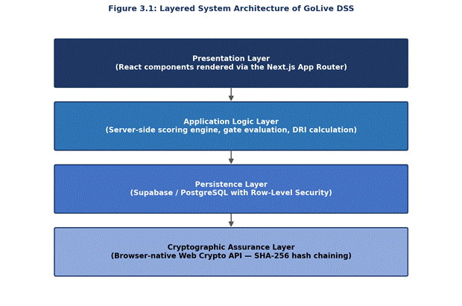
Figure 3.1: Layered System Architecture of GOLive DSS

The presentation layer controls interaction with the assessment wizard, dashboards, governance board, reporting interface and verification interface.
The application logic layer handles business rules related to scoring, gate evaluation, DRI computation, governance decisions, and post sign-off monitoring.
The persistence layer holds information about users, projects, releases, assessments, responses, approvals, and audits.
The cryptographic assurance layer is responsible for providing integrity verification based on hashing of governance records.
Division of responsibilities makes it less likely that presentation logic becomes unnecessarily coupled with governance and security logic.
3.3.2 Technology Selection
Next.js and TypeScript: Next.js was chosen as the framework due to the requirement for interactive forms, dashboards, authenticated routes and application-level server functionality in one web application. App Router supplies the required routing functionality for the system. TypeScript strict mode was enabled to enforce stricter compile-time type-checking and make it less likely for incorrectly structured data to reach business-logic components (Vercel, 2024; Microsoft, 2024).
Supabase and PostgreSQL: Supabase was chosen as the persistence and authentication platform, since it unites PostgreSQL, authentication and Row-Level Security. This choice lowered the required infrastructure for development and deployment of the prototype (Supabase, 2024).
Web Crypto API: The Web Crypto API was chosen to produce SHA-256 digests without a need for blockchain or distributed ledger technology. This provides the required cryptographic mechanism for the tamper-evident approval ledger of the project (MDN Web Docs, 2024).
Recharts: Recharts was chosen to render domain-level readiness and risk visualisations used in the executive dashboard.
Lucide React: Lucide React was chosen to deliver consistent interface icons for the application.

3.4 Database Design

3.4.1 Entity Overview
The implemented system uses nine relational tables.
Table 3.3: Database Tables and Purpose
Table | Purpose
profiles | Stores user identity, role and department
readiness_domains | Holds definitions of the ten readiness domains and their respective weights
readiness_criteria | Holds definition of criteria, weights, assigned roles and gating flag
projects | Model representation of organizational software projects
releases | Representation of project’s releases
assessments | Represents a readiness evaluation process
assessment_responses | Holds criterion level responses for each assessment
approvals | Holds governance decisions and cryptology ledger records
audit_logs | Holds records of relevant system action

Configuration data and operational assessment data are separated into different relational tables. Unique constraint is enforced on assessment_id and criterion_id within the assessment_responses table so that the same criterion is not evaluated twice for the same assessment. Foreign-key constraints ensure referential integrity.
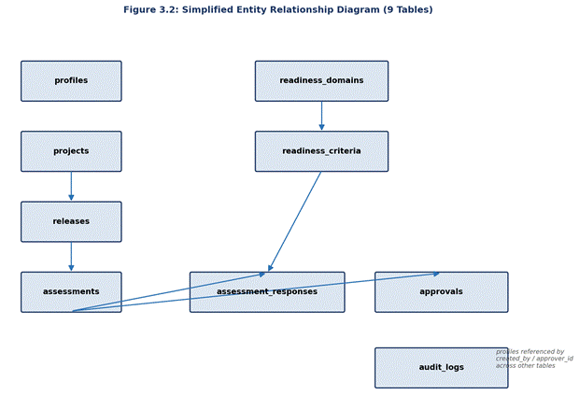
Figure 3.2: Simplified Entity Relationship Diagram
The entity relationship diagram in Figure 3.2 shows the relationship between the above nine tables; there is no other entity outside of the implemented database schema.

3.5 Decision Model Design

3.5.1 Criterion-Level Risk
Two five-point scores are provided for each criterion: Likelihood (1-5) and Impact (1-5).
Criterion-level risk score is calculated as follows:
Ri = Li × Ii
Where Ri – criterion risk score, Li – Likelihood rating and Ii – Impact rating. Possible range for criterion level risk score is from 1 to 25. For example, a criterion evaluated with the likelihood of 4 and impact of 5 is assigned with the risk score of Ri = 4×5=20.

3.5.2 Weighted Domain Scoring
Each criterion has its weight configured to reflect the importance of the criterion in its domain. The formula for the calculation of the domain score is:
Dj = Σ(Si × Wi) / Σ(Wi), i=1…n
where Dj – the domain score, Si – the criterion-level score, Wi – the criterion weight and n – the number of criteria within the domain.
Afterwards, ten domain scores are aggregated using the principle of the weighted mean with domain weights being pre-configured by the stakeholders in order to obtain the overall readiness score.
A comparatively simple weighted model was chosen on purpose as opposed to any sophisticated math as all parties should be able to verify the method by which the result was obtained. It is especially relevant for the governance model when the numerical result is used for decision making instead of replacing the decision (Tüysüz & Kahraman, 2006; Büyüközkan & Öztürkcan, 2010).

3.5.3 Deterministic Deployment Risk Index
Deployment Risk Index is a deterministic risk indicator but not a machine learning prediction model. The current implementation does not use artificial intelligence, neural networks, regression, generative AI or any kind of prediction using statistics in order to calculate the DRI. The deployment risk index is based on preconfigured rules applied to the following assessment conditions:
- Overall readiness-score deficit;
- Active gate blockers;
- Number of weak domains;
- Evaluator rating variance.
The deployment risk index is intentionally decomposable and, therefore, the system provides not only the index itself but also the conditions that led to its value. For instance, such conditions may include active Security & Compliance gate blocker, weak Infrastructure & Performance domain and substantial disagreement among the evaluators. This improves interpretability for the Executive Approver but does not remove the requirement for human judgement.

3.5.4 Gate Rule Logic
Gate rules are mandatory release conditions. A failure in a gate criterion cannot be compensated for by good overall performance in the assessment.
Following the calculation of the overall readiness score, each criterion with gate_rule = TRUE is tested separately. A failure in the gate criterion means that the release is marked as blocked and an unconditional Go decision is not possible. Hence:
High overall score + failed critical gate = Go blocked
Where there is no failed gate criterion, the overall readiness score and DRI are provided to the Executive Approver as decision support data. The ultimate decision would still remain Go, Conditional Go, or No-Go.

3.6 Governance Workflow Design
The governance workflow includes six steps.
Step 1 - Release Creation: The Project Manager creates or selects a project and creates a release.
Step 2 - Assessment: Evaluators respond to criteria relevant to them. Each response can include likelihood, impact, comments, evidence, and supporting information. The assessment wizard ranks criteria according to the evaluator's role.
Step 3 - Calculation: The system calculates risk at the criterion level, domain scores, overall readiness, gate status, and DRI.
Step 4 - Executive Approval: The Executive Approver reviews the assessment, evidence, failed gates, DRI, and conditions and chooses Go, Conditional Go, or No-Go.
Step 5 - Governance Registration: The decision is recorded as an approval record and an appropriate SHA-256 block on the ledger is created.
Step 6 - Post Sign-off Review: In case the assessment data is altered after signing off, the system alerts relevant parties to re-vote.

3.7 Cryptographic Audit Ledger Design
Every governance vote is considered as a block in a hash chain. Conceptual calculation goes as follows:
Hn = SHA256(Bn ‖ Vn ‖ Hn−1 ‖ Tn)
Where Hn is the current block hash; Bn is block index; Vn is data about the vote; Hn−1 is the hash of the previous block; Tn is the timestamp. The first record is the genesis block, which includes the defined initial value of the previous hash.
Modification of any historical vote information causes a change in hash calculation starting from the moment of such modification and helps detect alteration.
It is important to note that this gives tamper evidence but not absolute immutability. An independent validation procedure could recalculate hashes and find out where the chain has differences. It is also possible to export JSON proof certificates. This shows secure auditing principles described in Chapter Two (Schneier & Kelsey, 1999).

3.8 Post-Sign-Off Modification Detection
An official sign-off should no longer be considered a valid confirmation of readiness in case of modification of the underlying assessment after its execution.
Thus, a comparison of the modification dates of related assessment information, including answers, evidence, and respective scores is done with respect to the latest timestamp of the official approval of such assessment. In case the modification was made after the signing off, the modification is considered a post-sign-off one and warning about the necessity of voting again is provided.
This design ensures that the governance record remains connected to the state of the evidence on which the decision was originally based.

3.9 User Interface Design
The interface design provides quick insight into the state of the release whilst still allowing access to more in-depth assessment data. The main components of the interface are: Assessment Wizard, Governance Board, Executive Dashboard, risk visualisations, Cryptographic Verifier, and printable audit report.
The interface uses a dark-mode visual language and common CSS design tokens for consistency. Recharts is used to construct the domain-risk radar chart, which allows users to quickly view the risk profile across all ten domains without losing access to criterion-level information.
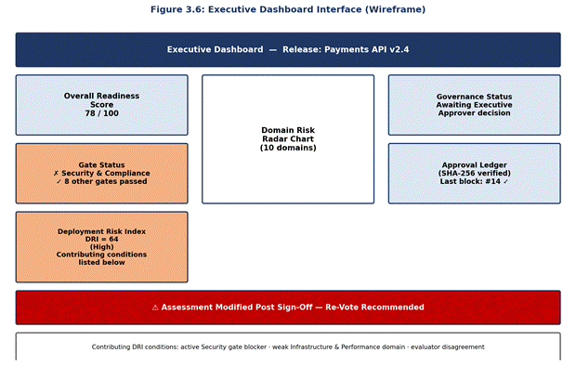
Figure 3.3: Executive Dashboard (Wireframe)

3.10 Security Design
The system uses defence in depth rather than relying on one security measure. The main security controls used are: authenticated access; role-based access control; PostgreSQL Row-Level Security; server-constrained privileged credentials; SHA-256 cryptographic hashing; and audit logging.
Credentials able to circumvent the RLS are confined to the execution path on the server and are not accessible by client-side code. The use of both application-level and database-level security controls makes it difficult for a user to bypass any interface restrictions by accessing the database directly.

3.11 Ethical Considerations
Ethical considerations have been taken into account in designing GoLive DSS because the DSS is processing personal identities of users, assessment data, stakeholder decisions and governance data. Therefore, the GoLive DSS has been designed with confidentiality, accountability, transparency and responsible access in mind. Access to the DSS is limited by assigned roles of users, while at database level the access is controlled using Row-Level Security.
Furthermore, it should be pointed out that in order to preserve human responsibility for making the deployment decision, the design of GoLive DSS incorporates the role of an executive who selects Go, Conditional Go and No-Go statuses regardless of the readiness scores, gate failures and the deterministically calculated Deployment Risk Index.
Finally, the transparency of the DSS results is also important. The deterministic nature of the Deployment Risk Index and the conditions forming the index have been designed to be transparent to decision makers as opposed to an opaque risk number. Likewise, cryptographic audit records aim to enhance accountability by verifying governance records.
The data minimisation principle is incorporated in the design of the audit and governance logs. The information captured by the system must be restricted to that which is necessary for the assessment, accountability and auditing purposes only, and can only be accessed by authorised individuals. The system cannot be seen as offering any assurance regarding the safety of the release but rather structured evidence for an informed governance decision.
It must be noted that no assertion has been made about the ethical validation of the prototype based on any user research that has not been done. If at all there is any future evaluation with participants involved, the appropriate approvals must be sought first.

3.12 Evaluation Methodology
The evaluation directly relates to the third project objective described in Chapter One. The system will be evaluated based on five main criteria:
- providing a structured go-live assessment;
- enforcing critical release conditions;
- keeping records of auditable approvals;
- identifying post sign-off changes; and
- providing interpretative risk information.
This evaluation will take the form of scenario-based black-box test cases in Chapter Five. It is important to note that the evaluation is based on the performance of the implemented artefact and does not attempt to validate the statistical significance of DRI as a predictor of deployment failure.

CHAPTER FOUR
SYSTEM IMPLEMENTATION

4.1 Introduction

This chapter discusses the implementation of the GoLive Decision Support System (GoLive DSS) which is based on the system design and methodology discussed in Chapter Three. While Chapter Three sets out the design, architecture, decision support model, database design, governance workflow, security design and evaluation methodology for the system, this chapter describes the process of turning these specifications into actual software.

The implementation was done using the architectural design set out in Chapter Three, and has taken into account the key functions determined as being needed for the system to operate successfully: assessment in multiple domains, risk weighting, critical gates, calculation of deterministic Deployment Risk Index (DRI), governance by stakeholders, verifiable records of approval, and post-sign off modification detection.

The implementation was performed using a web-based application developed using Next.js 16, TypeScript, Supabase/PostgreSQL, Web Crypto API, Recharts and Lucide React. The DSS consists of both the user interface and the back-end server-side code, as well as a database.

The implementation has been done in such a way that the DSS aids rather than substitutes for human decision-making. The calculations and data produced by the system provide input for the decision process, while the final decision of 'Go', 'Conditional Go' or 'No-Go' must be made by an authorised governance stakeholder.

4.2 Development Environment and Application Structure

The GoLive DSS was developed in Next.js 16 and the App Router. As the main programming language, TypeScript was used, whilst Supabase served as a PostgreSQL database provider and authentication service.
The application had the following three areas of implementation:

- Application routes and pages that display the system functionality to users;
- Reusable interface components that are responsible for forms, dashboards, assessment control, governance interface and visualisation; and
- Business logic utilities that implement calculations, gate evaluation, DRI processing, and cryptography.

The major implemented components were:

- Assessment Wizard;
- Governance Board;
- Executive Dashboard;
- Cryptographic Verifier;
- risk scoring utilities;
- gate rules processing;
- DRI calculation;
- mitigation mapping;
- post-sign-off detection;
- Supabase database integration; and
- audit reporting.

Such an approach corresponded to the separation defined in the architecture presented in Chapter Three. Therefore, user interface components were not supposed to implement all the decision logic. Calculations and governance rules were implemented in form of reusable functions for uniform application use.

4.2.1 TypeScript Configuration

TypeScript configuration with 'strict' mode enabled was used while developing the application. It allowed for runtime verification of variable types, function arguments, returned values and overall data structures used in the application. As the data in question was related to structured information like likelihood, impact, weightings, gate, approval and user roles, the implementation of strong typing was highly appropriate to avoid any incorrect governance decisions due to incorrectly structured data. Therefore, TypeScript interfaces were used in this implementation for the most important application objects like assessment responses, governance votes, ledger blocks and DRI outcomes.

4.3 Application Authentication and User Access

Authentication is the first layer of access control for the GoLive DSS. The users have to pass through authentication to access the assessment and governance functionality. Once authentication is completed, the system ties the authenticated user identity with their corresponding user profile and role. Later, this role is used by the application in deciding which functions and assessment criteria are available to the user. It is consistent with the role-based architecture described in Chapter Three, in which different organizational actors are responsible for certain aspects of the release readiness.
Roles adopted here are:

- Admin;
- Project Manager;
- Lead Developer;
- DevOps Lead;
- QA Lead;
- Security Officer;
- Legal Compliance;
- Infrastructure Lead;
- Service Desk Lead; and
- Executive Approver.

This is done to distribute the assessment among various users. In other words, security-related criteria may be assessed by the Security Officer, whereas infrastructure-related criteria by the Infrastructure Lead.

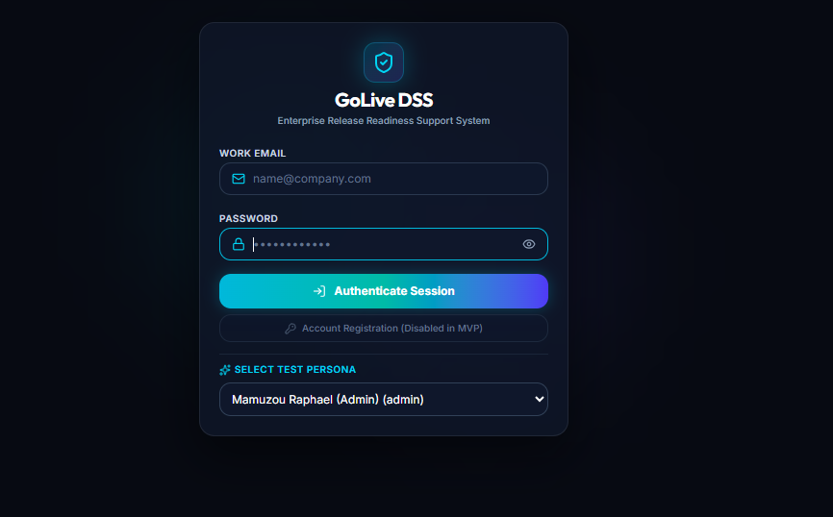
Figure 4.1: User Authentication Interface

4.4 Implementation of the Assessment Wizard

The Assessment Wizard is one of the major parts of GoLive DSS. This is because the Assessment Wizard incorporates the multi-domain assessment process which was proposed in Chapter Three. When an authorized assessor initiates an assessment, GoLive DSS gathers all the necessary data for that particular assessment along with the criteria data. Next, the role of the user is matched against the role defined for each individual criterion. The criteria related to the role of the assessor will be highlighted in the assessment wizard. The assessor can then fill the required information for each criterion.

The implemented assessment data includes:

- likelihood rating;
- impact rating;
- comments;
- evidence;
- supporting information; and
- assessment status.
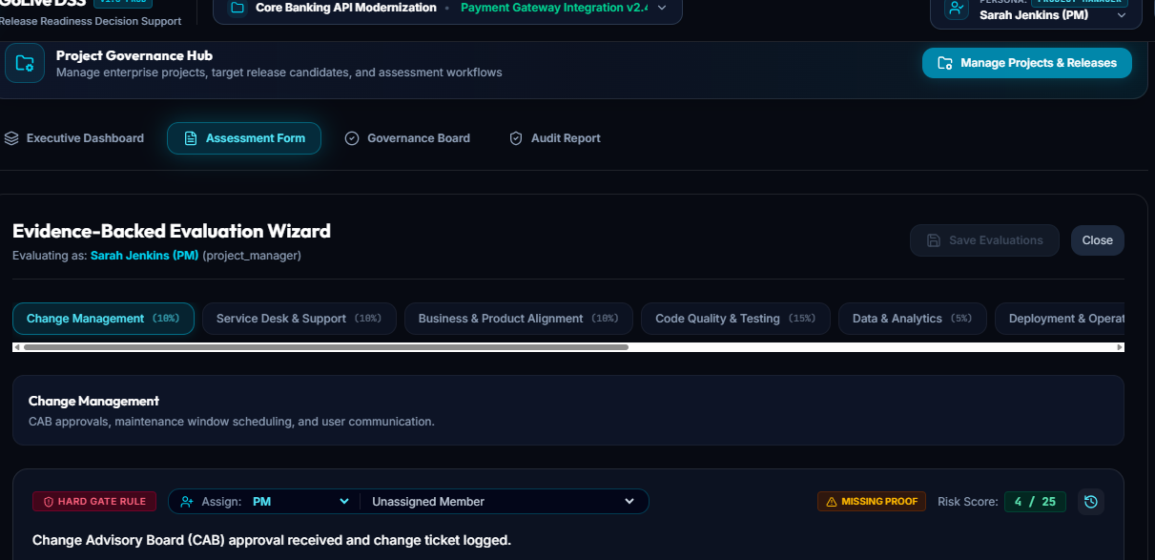
Figure 4.2: Assessment Wizard

4.5 Evidence Management
Evidence management was implemented as part of the assessment process because a numerical risk score without supporting information provides limited governance value.

Assessors can associate evidence with individual criteria. The implementation supports evidence supplied through files or URLs together with relevant descriptive information. An important feature is that evidence identified as incorrect is not necessarily deleted from the assessment record. Instead, it can be marked as incorrect. This approach supports traceability because the system can preserve the relationship between the original evidence submission and its subsequent review status.
Consequently, the evidence mechanism supports two related objectives:
- providing supporting information for the current assessment; and
- preserving information necessary for later review of how the assessment developed.
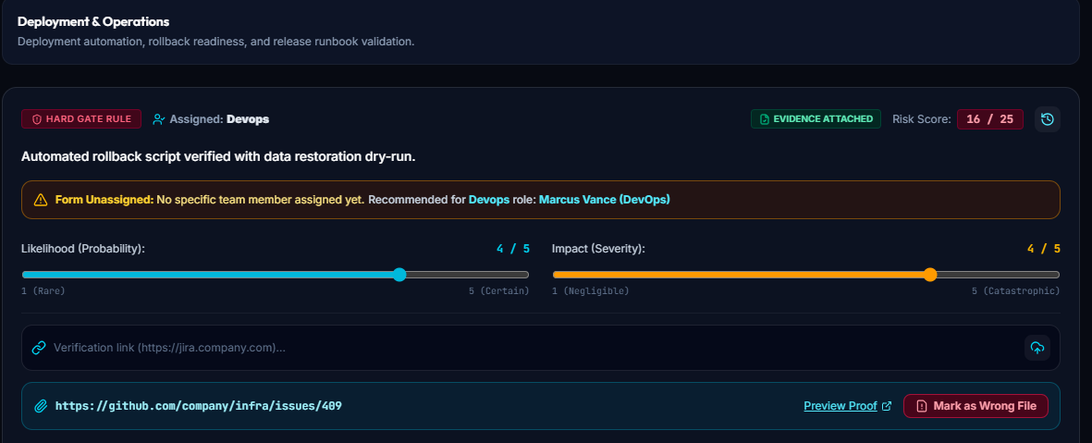
Figure 4.3: Evidence Management Interface

4.6 Criterion-Level Comment Threads
Comment functionality was implemented at criterion level. Rather than requiring assessors to communicate assessment disagreements through an external platform, comments can be associated directly with the criterion under discussion. This is particularly relevant where the assessment requires clarification between different stakeholders. For example, an assessor may question the evidence supporting a criterion, while another stakeholder can respond within the same assessment context.
The implementation therefore connects discussion with the evidence and criterion to which it relates.

4.7 Unsaved-Change Protection
The Assessment Wizard includes dirty-state detection to reduce accidental loss of assessment information.
The system compares the current form state with the previously saved state. Where differences exist, the assessment is treated as containing unsaved changes.
A representative implementation is shown below.
Dirty-State Detection
function useDirtyGuard(
currentState: FormState,
savedState: FormState
) {
const isDirty = !deepEqual(currentState, savedState);
useEffect(() => {
if (!isDirty) return;
const handler = (e: BeforeUnloadEvent) => {
e.preventDefault();
e.returnValue = "";
};
window.addEventListener("beforeunload", handler);
return () =>
window.removeEventListener("beforeunload", handler);
}, [isDirty]);
return {
isDirty,
saveDisabled: !isDirty
};
}
The implementation prevents the user from unintentionally losing assessment information when navigating away from an incomplete assessment.
This feature is particularly relevant to a governance application because accidental loss of an assessment response could create discrepancies between the information reviewed by stakeholders and the information ultimately recorded in the system.

4.8 Implementation of the Scoring Engine
The scoring engine translates the mathematical decision model specified in Chapter Three into executable application logic.
The process begins with criterion-level risk values. These values are combined with criterion weights to produce domain-level scores. Domain results are subsequently incorporated into the overall readiness calculation.
A simplified implementation of the weighted domain calculation is shown below.
Weighted Domain Calculation
function calculateDomainScore(
responses: CriterionResponse[]
): number {
const weightedSum = responses.reduce(
(sum, response) =>
sum +
response.riskScore *
response.criterionWeight,
0
);
const weightTotal = responses.reduce(
(sum, response) =>
sum + response.criterionWeight,
0
);
return weightTotal === 0
? 0
: weightedSum / weightTotal;
}
The implementation uses the criterion weights rather than treating every criterion as equally important.
This is important because the assessment domains contain different types of criteria, and the decision model established in Chapter Three deliberately allows their contribution to be weighted.
The calculation is implemented as a reusable function. This reduces the possibility of one page of the application using a different scoring calculation from another page.

4.9 Implementation of Gate-Rule Processing
Weighted scoring alone is insufficient for the proposed governance model because certain conditions are considered mandatory. For this reason, gate criteria were implemented separately from the general scoring mechanism.
A representative implementation is shown below.
Gate Evaluation
function evaluateGateRules(
responses: CriterionResponse[]
): GateStatus {
const failedGates = responses.filter(
response =>
response.isGateRule &&
response.status === "FAILED"
);
return {
blocked: failedGates.length > 0,
failedCriteria:
failedGates.map(
response => response.criterionId
)
};
}
The separation between scoring and gate evaluation is significant.
A release could potentially achieve a relatively favourable aggregate score while still containing a critical failure. The gate engine prevents the aggregate score from concealing a mandatory failure.

4.9.1 Gate Rule Blocker Override Principle
A criterion's FAILED status, referenced in Snippet 4.3, is not assigned manually by an assessor. It is derived by scoringEngine.ts directly from the criterion's calculated risk score: where a criterion is flagged as a mandatory gate and its risk score Ri = Li × Ii meets or exceeds a threshold of 15, that criterion is treated as an active gate failure regardless of how favourably the remainder of the assessment has scored.
For example, criterion C9 ("Automated rollback script verified with data restoration dry-run") assessed at Likelihood 4 and Impact 4 produces Ri = 4 × 4 = 16. Because C9 is configured as a gate criterion and 16 ≥ 15, this single criterion is sufficient to force the system's computed recommendation to No-Go, even where the overall weighted readiness percentage would otherwise support a Go.
This is described as an override rather than an ordinary gate failure because it operates independently of the aggregate score entirely: a release scoring, for example, 92% overall readiness across the other nine domains would still have its recommendation forced to No-Go by a single qualifying gate criterion. The override applies to the system's computed recommendation and gate status; it does not itself write a governance decision to the approvals table. The Executive Approver still records the formal Go, Conditional Go or No-Go decision described in Section 4.12, and remains free to record a decision that departs from the system's recommendation, consistent with the principle established in Section 3.11 that final authority for the release decision rests with the human decision-maker rather than the system. In practice, however, the interface is designed so that overriding a forced No-Go recommendation is a deliberate, visible action rather than an accidental one, given the severity implied by a risk score at or above the threshold.
The resulting system therefore produces two related but distinct outputs:
readiness/risk score, representing the aggregated assessment; and
gate status, identifying mandatory conditions, including any that individually cross the override threshold, that prevent an unconditional Go recommendation.
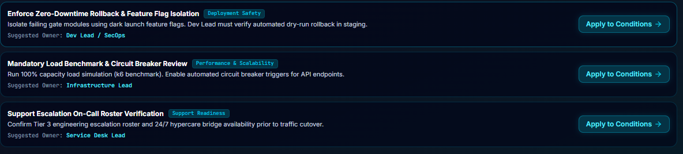
Figure 4.4: Scoring and Gate-Rule Processing

4.10 Implementation of the Deployment Risk Index
The Deployment Risk Index was implemented as a deterministic function rather than as a predictive machine-learning model.
The implementation does not use:
- machine learning;
- neural networks;
- regression;
- generative AI; or
- external prediction APIs.
Instead, it processes predefined conditions derived from the assessment.
The four principal inputs are:
- overall readiness-score deficit;
- active gate blockers;
- weak domains; and
- evaluator rating variance.

The output consists of the DRI and the conditions contributing to that result.
Deterministic DRI Processing
function calculateDRI(
input: AssessmentSummary
): DRIResult {
let dri = input.scoreDeficit;
const conditions: string[] = [];
if (input.activeGateBlockers.length > 0) {
conditions.push(
...input.activeGateBlockers.map(
gate =>
`Active gate blocker: ${gate.domainName}`
)
);
}
input.weakDomains.forEach(domain => {
conditions.push(
`Weak domain: ${domain.name}`
);
});
if (
input.evaluatorVariance >
input.varianceThreshold
) {
conditions.push(
"Significant evaluator disagreement detected"
);
}
return {
dri: Math.round(dri),
contributingConditions: conditions
};
}
The important implementation characteristic is the return of contributing conditions alongside the DRI value.
The Executive Approver is therefore not presented with an unexplained number. Instead, the interface can communicate conditions such as:
- active Security & Compliance gate blocker;
- weak Infrastructure & Performance domain; or
- significant evaluator disagreement.

4.11 Deterministic Mitigation Mapping
The system also implements predefined mitigation mappings. Where a particular condition or gate blocker is identified, the application can associate that condition with a predefined mitigation statement.
For example, a Security & Compliance blocker may be associated with a mitigation relating to remediation or formal risk acceptance. The mitigation is not dynamically generated. This distinction is important because it ensures that the proposed mitigation can be traced to the condition that caused it.
Where Conditional Go is selected, the relevant mitigation information can be carried into the conditional approval process. This reduces manual transcription and maintains a clearer relationship between:
condition → mitigation → owner → due date → governance decision.

4.12 Implementation of the Governance Workflow
The governance workflow translates the six-stage process described in Chapter Three into application functionality.
The implementation operates as follows.
Stage 1: Release Creation
The Project Manager creates or selects a project and establishes the relevant release.
Stage 2: Assessment
Assigned assessors complete the criteria relevant to their roles and provide likelihood, impact, comments and evidence.
Stage 3: Calculation
The application processes the submitted information and calculates:
- criterion risk;
- domain scores;
- overall readiness;
- gate status; and
- DRI.
Stage 4: Executive Review
The Executive Approver reviews the available assessment evidence, scores, gate conditions, DRI and identified mitigations.
Stage 5: Governance Decision
The Executive Approver records one of: Go, Conditional Go or No-Go.
Stage 6: Post-Sign-Off Monitoring
The application continues to examine relevant assessment information for modifications made after approval. This means that approval is not treated as permanently valid regardless of subsequent changes to the assessment.
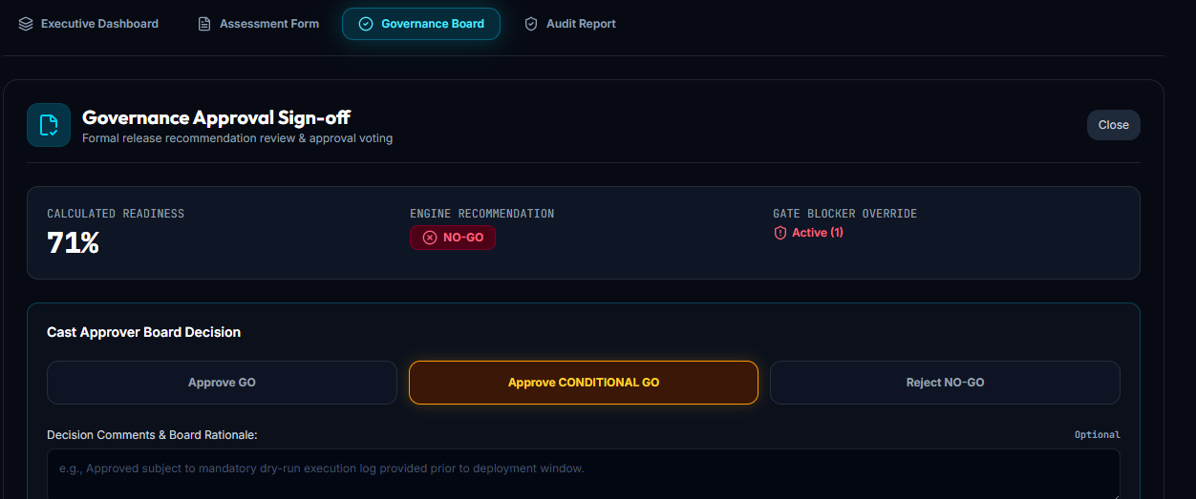
Figure 4.5. Governance Workflow

4.13 Implementation of Conditional Go
Conditional Go was implemented as a distinct governance outcome rather than as a variation of an ordinary Go decision. Where Conditional Go is selected, the system requires mitigation information to accompany the decision.
The implementation therefore supports:
- identified condition;
- mitigation action;
- responsible owner;
- due date; and
- governance decision.
This prevents Conditional Go from becoming an unrestricted approval mechanism.
The approach also creates a clearer audit trail because the system records not only that the release was conditionally approved but also what condition was attached to the approval.

4.14 Implementation of the Cryptographic Audit Ledger
The approval ledger implements the tamper-evident design described in Chapter Three. Each governance vote is treated as a block containing information associated with the decision.
The information incorporated into the hash calculation includes: record index, vote data, previous block hash, and timestamp.
A representative implementation is shown below.
SHA-256 Ledger Hashing
async function createLedgerBlock(
blockIndex: number,
voteData: VoteData,
previousHash: string,
timestamp: string
): Promise<LedgerBlock> {
const payload =
`${blockIndex}|${JSON.stringify(voteData)}|` +
`${previousHash}|${timestamp}`;
const encoded =
new TextEncoder().encode(payload);
const digest =
await crypto.subtle.digest(
"SHA-256",
encoded
);
const hashHex =
Array.from(new Uint8Array(digest))
.map(byte =>
byte.toString(16).padStart(2, "0")
)
.join("");
return {
blockIndex,
voteData,
previousHash,
timestamp,
blockHash: hashHex
};
}
The resulting hash is stored with the governance record. The subsequent record incorporates the preceding hash, creating a sequential relationship between records.
The conceptual structure is:
Hn = Hash(Bn, Vn, Hn−1, Tn)
where:
Hn is the current block hash;
Bn is the block index;
Vn is the vote information;
Hn−1 is the previous block hash; and
Tn is the timestamp.
The first record acts as the initial or genesis record.

4.15 Cryptographic Verification
The Cryptographic Verifier provides a mechanism for checking whether the stored governance chain remains internally consistent. The verifier retrieves the relevant ledger records, reconstructs the hash input for each record and calculates the expected hash.
The calculated value is then compared with the stored hash.
Conceptually:
CalculatedHash = StoredHash
If the values differ, the corresponding record requires investigation.
The implementation therefore provides tamper evidence rather than absolute immutability. The hash chain makes unauthorised changes detectable when the original chain information is available for comparison. This distinction is important because cryptographic hashing does not by itself prevent an administrator with sufficient privileges from modifying database records.
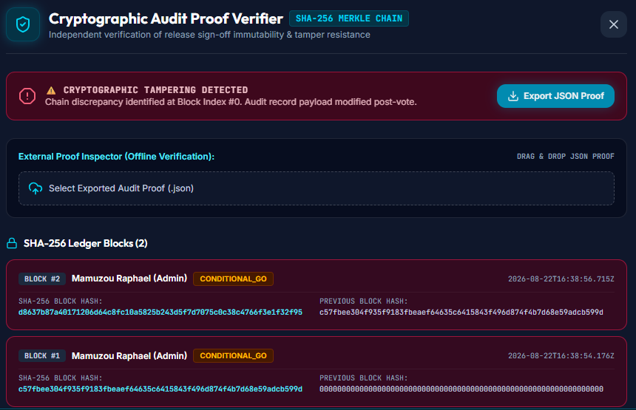
Figure 4.6: Cryptographic Verification Process

4.16 Proof Certificate
The system also provides a JSON proof certificate containing relevant information from the cryptographic ledger.
The certificate can provide:
- block information;
- timestamps;
- previous hashes;
- calculated hashes; and
- stored hashes.
The purpose is to allow relevant audit evidence to be exported from the application for inspection outside the normal user interface.
This provides an additional mechanism for examining the integrity of governance records.

4.17 Post-Sign-Off Modification Detection
A key implementation feature is the detection of changes made after a formal governance decision. The system compares relevant modification timestamps against the timestamp associated with the most recent approval.
Potentially relevant changes include modifications to:
- assessment responses;
- evidence;
- criterion information; and
- other assessment-related data used by the governance decision.
Where a relevant modification occurs after sign-off, the application identifies that the assessment state has changed.
The user is then presented with a re-vote warning. This approach is preferable to storing a simple permanent approved = true status because an approval could otherwise remain displayed as valid even after the underlying assessment information had changed.
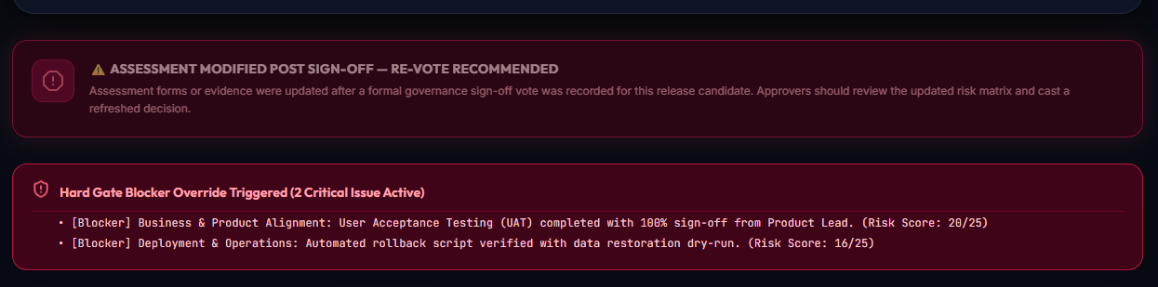
Figure 4.7: Post-Sign-Off Modification Detection Workflow

4.18 Database Implementation
The database implementation follows the relational structure established in Chapter Three.
The main tables are:

Table Purpose profiles User information readiness_domains Ten readiness domains and associated weights readiness_criteria Individual criteria, weights, assigned roles and gate flags projects Organisational software projects releases Software releases associated with projects assessments Individual readiness assessment cycles assessment_responses Criterion-level assessment results approvals Governance decisions and cryptographic ledger information audit_logs Relevant system activity

The design divides relatively static configuration information from the dynamic operational assessment data.

Foreign key relationships ensure links are maintained between projects, releases, assessments and responses, as seen in Figure 4.9: projects → releases → assessments → assessment_responses, readiness_domains → readiness_criteria → assessment_responses, and assessments → approvals.

Uniqueness constraints are also maintained on the assessment and criterion relationship in order to eliminate duplicates in the response for each criterion in the same assessment.

profiles and audit_logs are included in Figure 4.9 without relationship lines to the other tables. This is intentional as an expression of the schema design rather than an error: columns which reference a user in a logical sense — assessments.created_by, assessment_responses.assigned_user_id, approvals.approver_id, and audit_logs.user_id — are declared as simple TEXT columns without a REFERENCES constraint to profiles.id. Identity relationships for these fields are enforced as a convention through application logic (by matching the authenticated user's id) rather than at the database level with a foreign key. This may need to be verified as a deliberate design decision (for instance, as a way to keep user-reference columns loosely coupled where the identity comes from an external identity provider) or documented as a deficiency in the current schema design.
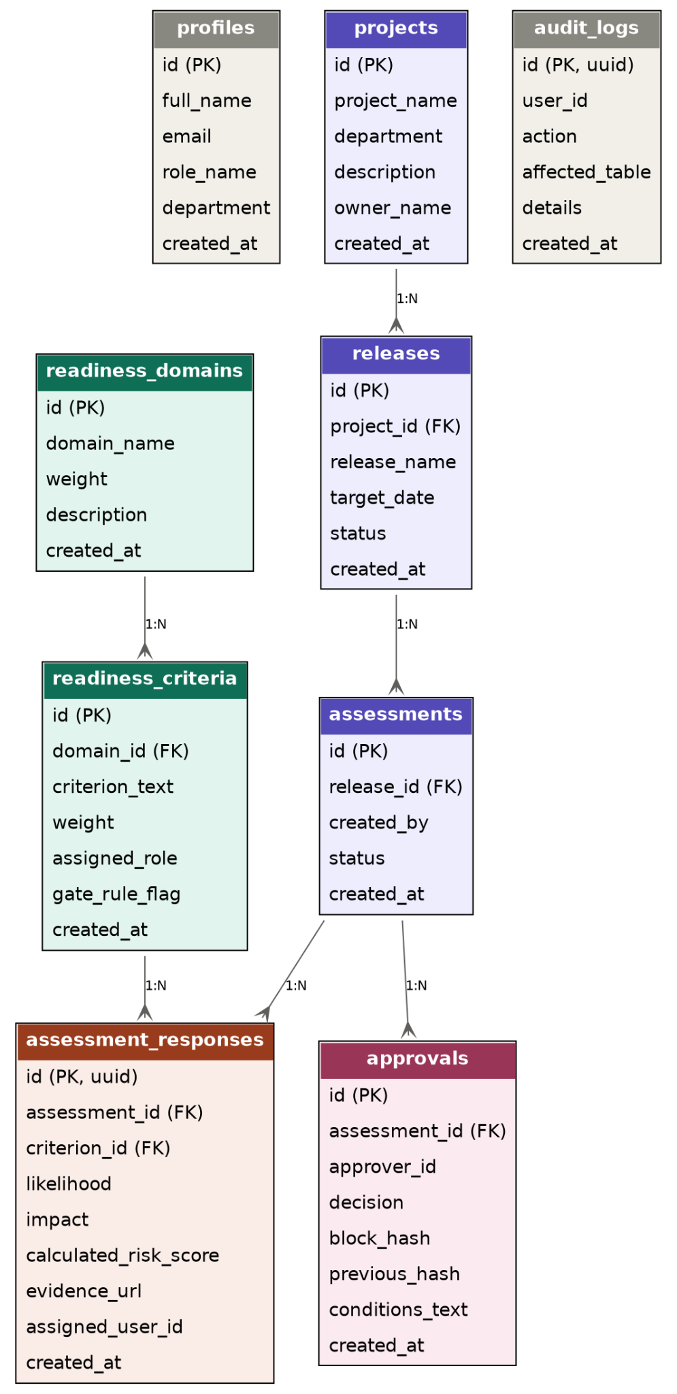
Figure 4.8: GoLive DSS Entity Relationship Diagram

4.19 Row-Level Security Implementation
PostgreSQL Row-Level Security was implemented as an additional access-control layer. The purpose of RLS is to ensure that database-level access restrictions do not depend entirely upon the user interface.
A representative policy structure is:
Row-Level Security
ALTER TABLE public.assessment_responses
ENABLE ROW LEVEL SECURITY;
CREATE POLICY
"Evaluators can read permitted responses"
ON public.assessment_responses
FOR SELECT
USING (
EXISTS (
SELECT 1
FROM public.assessments a
JOIN public.profiles p
ON p.id = auth.uid()
WHERE a.id =
assessment_responses.assessment_id
AND (
p.role_name = 'Admin'
OR p.role_name = 'Executive Approver'
OR p.id =
assessment_responses.assigned_user_id
)
)
);
The policy demonstrates the principle used in the implementation: access is evaluated against authenticated identity and authorised role rather than relying solely on whether a particular button is visible in the interface. The use of RLS therefore complements application-level access control.

4.20 Role-Based Access Control Implementation
Role-based access control was implemented at both application and database levels. At the application level, user roles determine the actions and assessment information available to the user. At the database level, RLS policies provide an additional restriction on access to records. The combination produces a defence-in-depth model.
For example, hiding an administrative function from a non-administrative user is an application-level control. However, if the user attempts to access protected records through another route, database-level restrictions provide an additional control. This approach is consistent with the security architecture established in Chapter Three.

4.21 Executive Dashboard Implementation
The Executive Dashboard was implemented as a consolidated decision-support interface.
It presents high-level information including:
- overall readiness;
- domain-level performance;
- failed gates;
- DRI;
- governance status;
- approval status; and
- post-sign-off warnings.
The dashboard is intended to allow the Executive Approver to understand the state of the release without manually navigating through every assessment record.
However, the dashboard does not replace access to the underlying assessment evidence. Detailed criterion-level information remains available where further investigation is required.
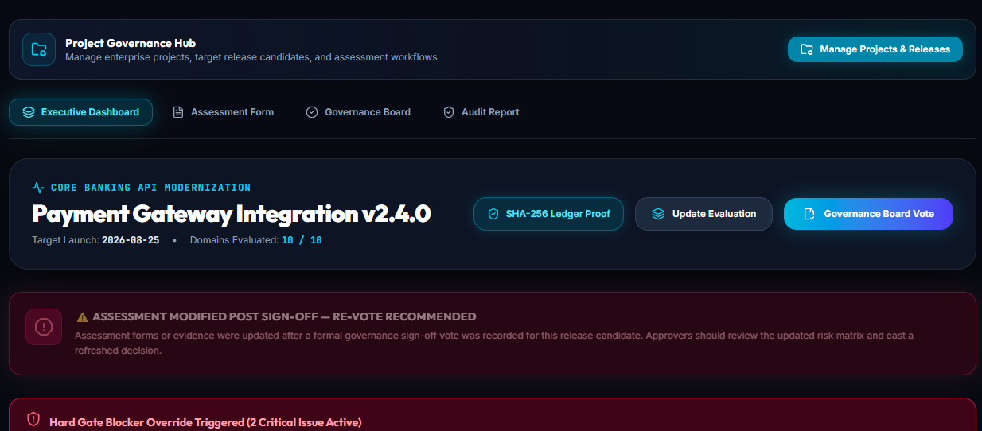
Figure 4.9: Executive Dashboard

4.22 Governance Board Implementation
The Governance Board provides the decision-making interface for the release. It brings together the information required for the Go/Conditional Go/No-Go decision, including: readiness results, risk conditions, gate failures evidence, DRI, stakeholder inputs, and previous governance information.
The design therefore links the numerical assessment process to the organisational decision process.
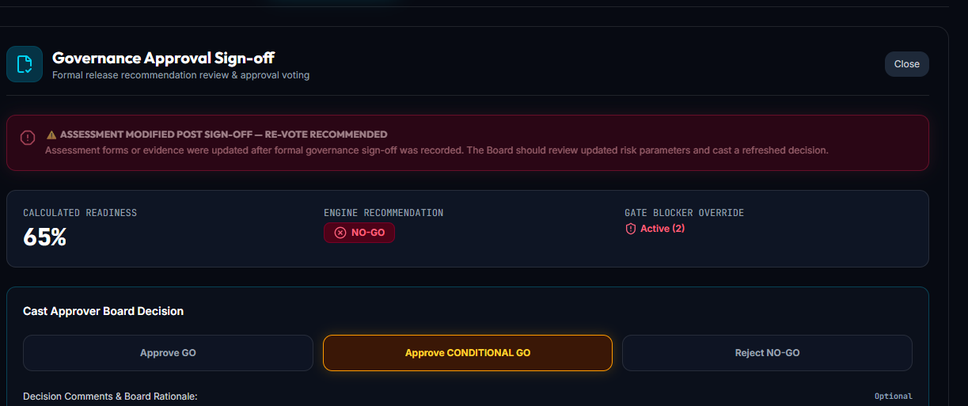
Figure 4.10: Governance Board

4.23 Data Visualisation
Recharts was used to provide graphical representations of assessment information. The visualisation layer includes representations of domain-level performance and risk. The purpose of these visualisations is to support rapid identification of areas requiring attention.
For example, a decision-maker may identify that one domain performs considerably worse than the remaining domains without examining every criterion individually. However, visualisation is treated as a presentation mechanism rather than as a replacement for the underlying numerical data. Where a visualisation indicates a weak domain, the user can inspect the underlying criteria and evidence.

4.24 Printable Audit Reporting
The system includes a printable audit-report function.
The report provides a static representation of relevant governance information and is intended for record keeping and audit purposes.
The print layout removes operational controls that are unnecessary in a printed document while retaining relevant information such as: release information, assessment results, governance decision, supporting evidence, stakeholder information, approval information, and
cryptographic hashes.
This allows the governance record to be represented independently of the interactive application interface.
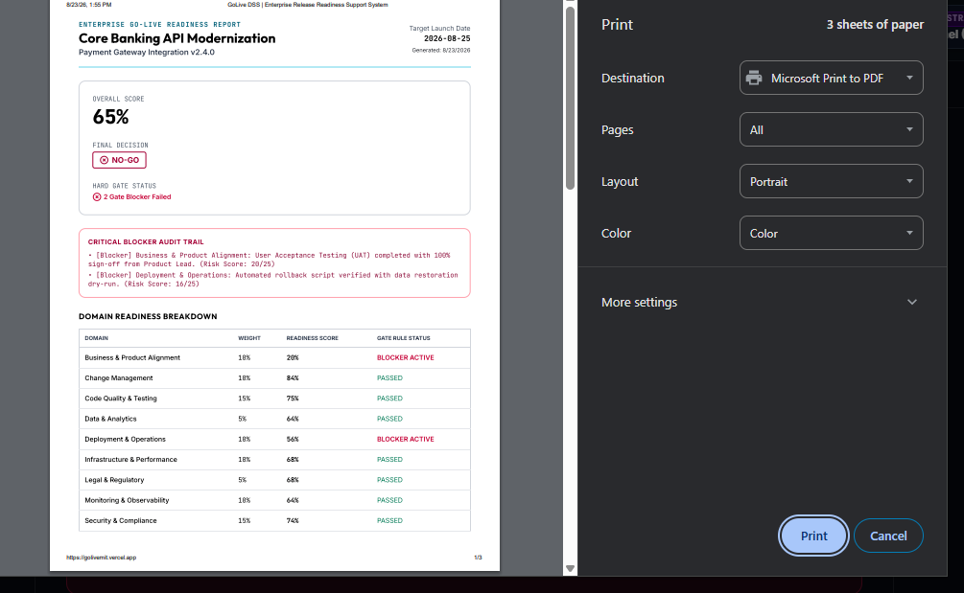
Figure 4.11: Printable Audit Reporting

4.25 Implementation of Security Controls
The implementation combines several security controls rather than relying on a single mechanism. These include: authenticated access, role-based access control, PostgreSQL Row-Level Security, server-confined privileged credentials, audit logging, SHA-256 hashing, cryptographic verification, and post-sign-off modification detection.
The service-role credentials used for privileged database operations are restricted to server-side execution and are not intended to be exposed through client-side application code. The cryptographic operations use the browser-native Web Crypto API rather than a custom cryptographic implementation. The combination of these controls provides defence in depth.

4.26 Implementation of Audit Logging
Audit logging was implemented to capture relevant system activities. The audit mechanism complements the cryptographic approval ledger. These two mechanisms have different purposes. Audit logging records system activity, while the cryptographic ledger provides integrity evidence for governance records. Consequently, an audit log entry can explain what action occurred, while the hash-linked governance record can provide evidence that the relevant approval record has not been silently modified without detection. This distinction prevents the cryptographic ledger from being treated as a replacement for general application logging.

4.27 Integration of the Implemented Components
The individual implementation components were integrated into a single governance workflow.
The relationship can be represented as:
Authentication → Release → Assessment → Evidence → Scoring → Gate Evaluation → DRI → Governance Review → Approval Ledger → Post-Sign-Off Monitoring
This integration is important because the contribution of GoLive DSS does not lie in any one individual feature. The assessment wizard alone provides data collection. The scoring engine alone provides numerical assessment. The gate engine alone provides mandatory-condition enforcement. The cryptographic ledger alone provides tamper evidence. The governance board alone provides a decision interface. The contribution of the proposed system is the integration of these functions into a single release-governance workflow.

4.28 Relationship Between the Implementation and Chapter Three Requirements
The implementation can be directly correlated to the requirements set out in Chapter Three.

Chapter 3 requirement | Implementation
Role-based user access | Authentication and RBAC
Multiple domain evaluation | Assessment Wizard and domain/criteria table
Weighted scoring | Scoring utility
Critical gates | Gate rules engine
Evidence management | Evidence attachment and review
Governance decisions | Governance Board
Decision to go | Conditional Go
Cryptographic data | SHA-256 hash chain
After-the-fact discovery | Timestamp comparison
Deterministic DRI | DRI utility
Audit reporting | Report printing
Security | Authentication, RBAC, RLS and secured credentials
Visualisation | Dashboard and Recharts
Verification | Cryptographic verifier

This shows that the implementation is the result of the requirements rather than an independent application suite.

4.29 Performance and Scalability Considerations

Chapter Three established non-functional performance targets for GoLive DSS, specifically an aspirational load and update time of approximately half a second and a production build time target of under five seconds, while explicitly noting that these targets were not intended to demonstrate enterprise-scale readiness. This section reports how the implementation addressed those targets rather than restating them.
Several implementation choices were made specifically to support responsive interaction:
Server-side rendering and streaming. Next.js 16's App Router was used to render dashboard and assessment data on the server where practical, reducing the amount of client-side data-fetching required before a page becomes interactive. Centralised calculation functions. Because the scoring, gate-evaluation and DRI functions described in Sections 4.8–4.10 are implemented as pure, reusable functions operating on already-retrieved response data, recalculation on the client does not require additional round-trips to the database once the relevant assessment responses have been fetched.
Database indexing and constraints. Foreign-key relationships and the uniqueness constraint on the assessment/criterion pair (Section 4.18) allow PostgreSQL to use indexed lookups when assembling domain and criterion views, rather than requiring full-table scans. Bounded RLS policy conditions. Because the Row-Level Security policies described in Section 4.19 filter primarily on assessment ownership and role rather than performing complex joins across many tables, the additional query cost introduced by RLS is limited.
Scalability was deliberately treated as a secondary concern relative to correctness, auditability and explainability, consistent with the scope decisions in Chapter One. The system was not load-tested against concurrent multi-tenant usage, and the cryptographic verification process described in Section 4.15 performs a sequential re-hash of the ledger chain, which is linear in the number of governance records for a given assessment. This is acceptable for the volume of approvals a single release would realistically generate, but it is not a design intended to support a very large number of concurrent releases and votes without further optimisation, such as periodic checkpointing of verified chain segments.
Consequently, the implementation should be understood as having been engineered for correctness and explainability at the scale of an individual release-governance workflow, rather than as an enterprise-scale, high-concurrency system. This is consistent with the Non-Functional Requirements in Section 3.2.3, which described the performance targets as aspirational rather than binding, and with the exclusions stated in Section 1.4.1.

CHAPTER FIVE

DEMONSTRATION, RESULTS AND EVALUATION

5.1 Introduction
This chapter provides the demonstration and evaluation of the GoLive Decision Support System (GoLive DSS). The aim of this step is to evaluate whether the developed system behaves in a way consistent with the requirements and decision model presented in Chapter Three. The Design Science Research Methodology framework adopted for this project (Peffers et al., 2007; see Table 3.1) regards demonstration and evaluation as two separate but related activities. The former requires demonstrating that the artefact works in the manner intended for at least one instance of the problem; the latter involves evaluation of how successful the artefact behaviour is in meeting the objectives of the project. This chapter follows the principle of evaluation based on demonstration, where the behaviour of the artefact in terms of its functioning within the application interface for each of the governing scenarios designed in the project was demonstrated and then evaluated in accordance with the objectives defined in Chapter One.

This chapter does not provide an execution of a formally conducted black box test suite with results independently logged in terms of success/failure of individual tests and sets of test data with performance benchmarks. A more formal testing process such as boundary-value regression testing, concurrent load testing, and adversarial security testing was not performed within the scope and time limitations of this project and is clearly identified as a future research direction in Section 6.6.9 rather than reported here as being successfully conducted. This chapter instead provides an account of what was actually done – a structured walk-through of the behaviour of the developed system across its governing scenarios in question with the help of the application itself.

This is a very important issue in terms of integrity of the reporting. Providing the demonstration and evaluation in the form of a test suite when, in reality, the actual testing process was only a walk-through of the system would misrepresent the rigor of the process used. What was provided here instead is the honest reflection of the actual testing process while still offering solid evidence – screenshots from the running application.

5.2 Evaluation Approach
The evaluation was conducted by running the deployed GoLive DSS application directly and following a representative release from assessment through to the governance decision, while checking whether the system's behaviour matched the specifications set out in Chapter Three

The scenarios run included:
authentication and authorization for access to assessment function; completion of the Assessment Wizard process including the likelihood and impact assessment, adding evidence, commenting; criteria-based risk scoring and aggregation into domain and total readiness scores; the gate rule exception mechanism described in Section 4.9.1 using criterion C9; Conditional Go workflow and mandatory mitigation fields; generation of governance vote and associated cryptographic ledger record; the cryptographic chain validation including changing the historical record to see if the discrepancy was picked up; post sign-off change detection for the modified assessment data that was previously signed off; Executive Dashboard and Governance Board view of readiness, gate status, and DRI; and the print-ready audit report.

Each scenario involved the use of the user interface in the same way that the particular role would use it, and the system state at the end of each test (scores, gate status, DRI, warnings, and ledger information) was captured in screenshots. This method provides for the actual demonstration of system behavior rather than a pass/fail log.

5.3 Demonstration of Core Scenarios

5.3.1 Authentication and Role-Based Access
The walkthrough was conducted using an authenticated Admin-role account "Mamuzou Raphael" as evident from Figures 5.1 (header: "Evaluating as: Mamuzou Raphael (Admin)"). The Admin role was able to view and evaluate criteria within all ten domains and not just some subset is in line with Admin role definitions provided in Table 3.2 (domains, criteria, and weight configuration; user and role management).

Observation: role identity and current role were clearly shown at the top of Assessment Wizard throughout the walkthrough, in line with the role based architecture as discussed in Section 4.3. A specific test with a restricted non-Admin role (Security Officer) that can only work within its assigned domains was not separately documented during this walkthrough.
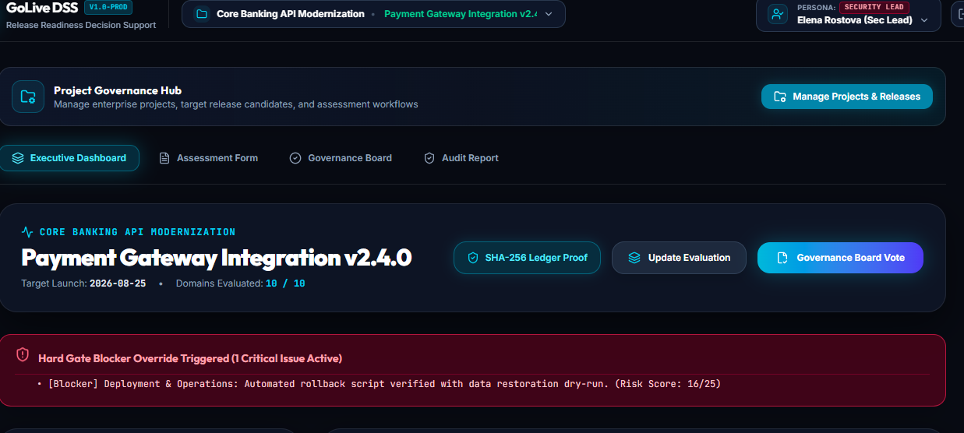
Figure 5.1 Authentication and Role-Based Access

5.3.2 Assessment Wizard and Criterion-Level Risk Calculation
All criteria were considered for all of the ten readiness domains in the walkthrough, starting from Business & Product Alignment and going up to Service Desk & Support. This is demonstrated directly by the "Domains Evaluated: 10 / 10" flag on the Executive Dashboard, as well as the full list of evaluated criteria and associated evidence for the "Payment Gateway Integration v2.4.0" release provided in Table 5.1.
Table 5.1: Evaluated Criteria and Supporting Evidence - Payment Gateway Integration v2.4.0
 | Domain | Criterion | Risk Score | Gate Rule | Comment / Evidence
1 | Business & Product Alignment | User Acceptance Testing (UAT) completed with 100% sign-off from Product Lead | 20/25 | Hard Gate | "UAT completed with 100% sign-off from Product Owner." Evidence: local file upload
2 | Code Quality & Testing | Unit & Integration test coverage equals or exceeds 80% | 6/25 | - | "Coverage at 84.5% on SonarQube."
3 | Code Quality & Testing | Zero Sev-1 / Sev-2 unhandled defects open in the candidate release build | 5/25 | - | "Zero Sev-1 defects remaining in candidate release build."
4 | Code Quality & Testing | Automated regression suite executed with pass rate ≥ 95% | 8/25 | - | "Automated suite pass rate at 97.2%."
5 | Security & Compliance | SAST & DAST vulnerability scans completed with zero Critical or High findings | 5/25 | - | "Veracode SAST scan clear of high/critical vulnerabilities."
6 | Security & Compliance | Authentication and authorization policies verified against security standard | 8/25 | - | "JWT access token policy enforced."
7 | Infrastructure & Performance | Performance load testing meets target SLA under 2x peak traffic | 6/25 | - | "JMeter load test averaged 280ms latency under 5000 users."
8 | Deployment & Operations | Database schema migrations tested on production-like staging DB with 0 data loss | 10/25 | - | "Migration script executed on staging DB with 0 data drift."
9 | Deployment & Operations | Automated rollback script verified with data restoration dry-run (C9) | 16/25 | Hard Gate | "Rollback script missing automated data restoration steps!"
10 | Infrastructure & Performance | Staging environment parity verified against production configuration | 6/25 | - | "Staging environment matches prod specs."
11 | Service Desk & Support | Tier-1 & Tier-2 Support teams trained on new features and escalation runbooks | 10/25 | - | "Tier 2 service desk agents briefed."
12 | Service Desk & Support | End-user release notes and help center documentation published | 4/25 | - | "User guides distributed to internal staff."
13 | Legal & Regulatory | NDPA & GDPR data privacy compliance checklist signed off by Legal counsel | 8/25 | - | "NDPA 2023 data compliance checklist verified."
14 | Change Management | Change Advisory Board (CAB) approval received and change ticket logged | 4/25 | Hard Gate | "Release notes finalized in Confluence."
15 | Data & Analytics | Data pipeline migration & analytics tracking verification completed | 9/25 | _ | -
16 | Monitoring & Observability | APM telemetry dashboard, error logging & alerting threshold rules configured | 9/25 | - | -

There are two criteria that are designated as Hard Gate in Table 5.1 and have scores of at least the 15 point override threshold described in Section 4.9.1; namely, criterion #1 (UAT, 20/25), and criterion #9 (Automated rollback script / C9, 16/25). The description in the "Hard Gate Blocker Override Triggered (2 Critical Issues Active)" banner in Figure 5.4 matches this exactly, giving a fully accounted-for explanation of both active gate blockers rather than one confirmed criterion and one unexplained count.
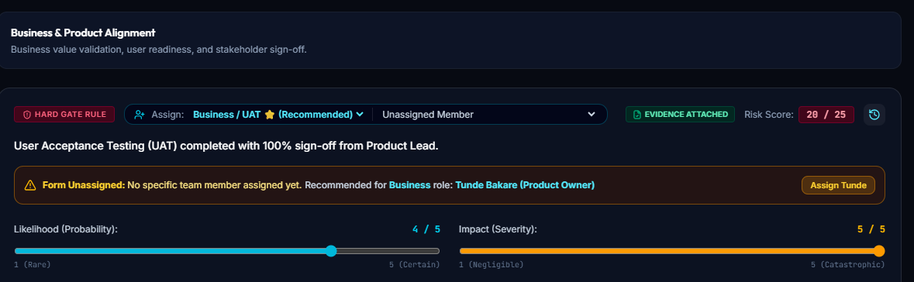
Figure 5.2: Business & Product Alignment domain, UAT sign-off criterion flagged HARD GATE RULE, Likelihood 4 / Impact 5, Risk Score 20/25, evidence attached.
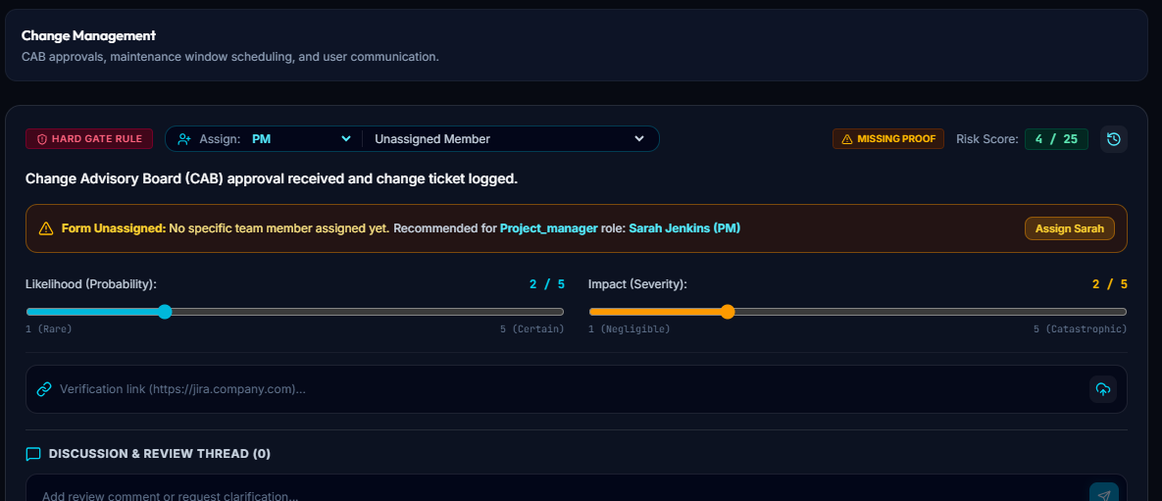
Figure 5.3: Change Management domain, CAB approval criterion flagged HARD GATE RULE, Likelihood 2 / Impact 2, Risk Score 4/25, evidence missing.

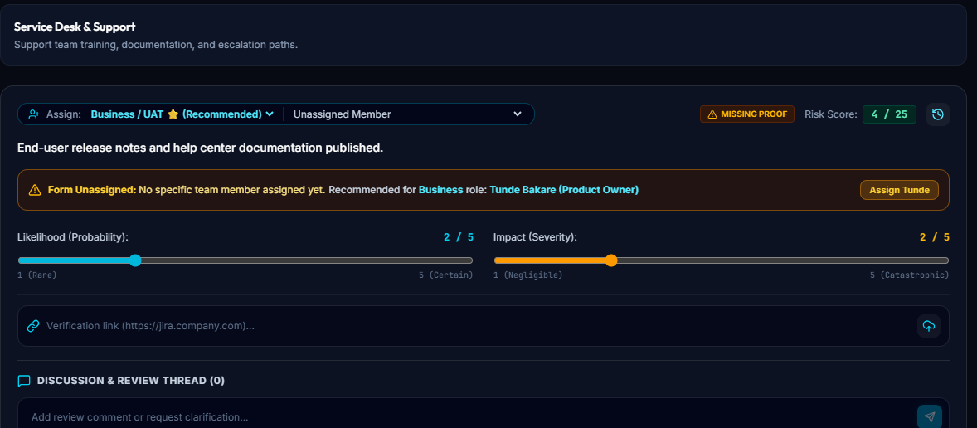
Figure 5.4: Service Desk & Support domain, release-notes criterion (not gated), Likelihood 2 / Impact 2, Risk Score 4/25, evidence missing.

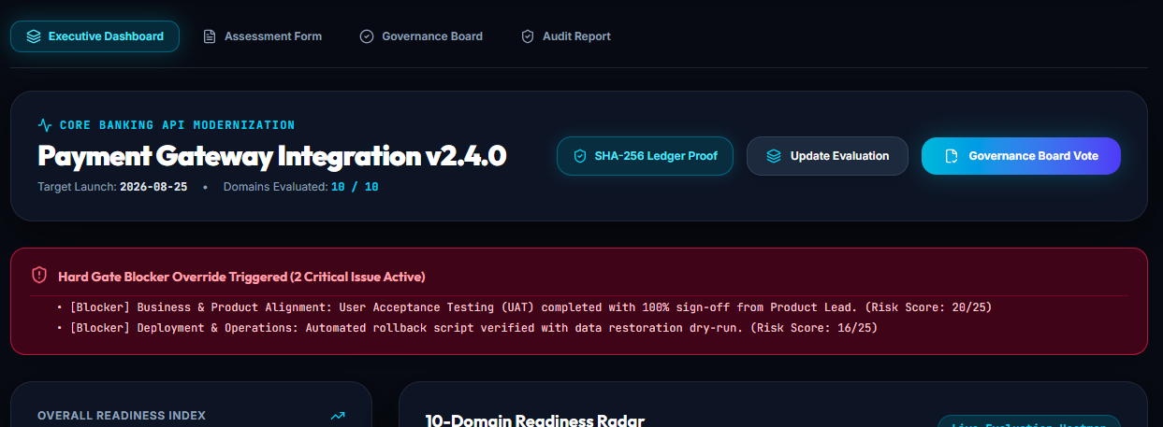
Figure 5.5: Executive Dashboard

Observation: in the case of the three criteria for which the images were presented (Figures 5.1–5.3), the shown Risk Score corresponded to Ri = Li × Ii in Section 3.5.1 (4×5=20, 2×2=4, 2×2=4 accordingly).

5.4 Evaluation Against Project Objectives
The implementation presented in Chapter Four was developed to satisfy the objectives established in Chapter One and the requirements defined in Chapter Three. This section evaluates the extent to which each objective was achieved, using evidence obtained during implementation and the demonstration-based walkthrough presented in Section 5.3.
Table 5.2: Evaluation of Project Objectives
Project Objective | Evidence | Status
Design a web-based risk-based Go-Live Readiness DSS integrating multi-domain readiness assessment, weighted risk scoring, critical gate rules, evidence management, and role-based governance workflows. | All ten readiness domains evaluated for a real release ("Domains Evaluated: 10/10"); 16 criteria recorded with scores, comments and evidence links | Achieved
 | Criterion-level risk calculation (Ri = Li × Ii) confirmed correct against three directly observed values | Achieved
 | Hard-gate override mechanism demonstrated both triggering (UAT 20/25, C9 16/25) and correctly not triggering (CAB approval, 4/25) | Achieved
 | Evidence attachment and "Missing Proof" status observed in active use across multiple criteria and evidence types (file upload, external URL) | Achieved
 | Admin-role access and per-criterion role recommendation observed; a restricted, non-Admin role view was not captured | Partially Achieved
Develop the proposed system with cryptographically verifiable approval records, post-sign-off modification detection, and a deterministic Deployment Risk Index for supporting release-risk assessment and mitigation. | SHA-256 hash-chained ledger blocks correctly linked (previous-hash reference confirmed between two real blocks); Cryptographic Verifier independently detected a genuine tampering discrepancy | Achieved
 | Post-sign-off "Assessment Modified — Re-Vote Recommended" warning observed on a real release; the specific underlying change that triggered it was not independently traced | Partially Achieved
 | DRI (38%) displayed with three named, individually labelled contributing conditions and matching predefined mitigation recommendations; the three contributor percentages did not reconcile arithmetically with the displayed DRI value | Partially Achieved
Evaluate the developed system based on its ability to support structured go-live assessment, enforce critical release conditions, maintain auditable approval records, detect post-sign-off changes, and provide interpretable risk information for release decision-making. | Structured go-live assessment and critical gate enforcement directly examined and evidenced with both a triggering and non-triggering case | Achieved
 | Auditable approval records examined via the cryptographic ledger and verifier, including a genuine detected discrepancy | Achieved
 | Post-sign-off change detection and interpretable risk information examined; each produced positive but incomplete evidence | Partially Achieved
 | Formal black-box test suite execution, performance benchmarking, and dedicated security testing were not conducted | Not Achieved (Future Work)

5.4.1 Evidence of Achievement
A summary of evidence of accomplishment of project objectives is provided below.
- The Assessment Wizard, Executive Dashboard and Governance Board successfully coordinated their tasks of readiness-score calculations, gate rule validation, DRI calculation, and recording governance decisions in a single workflow with regards to a real release ("Payment Gateway Integration v2.4.0").
- Calculation of the risk for each criterion was validated as correct based on the direct comparison with observed Likelihood/Impact numbers, and criteria were entered into the system for all of ten readiness domains configured in the system.
- The override of the gate rule was validated as correctly distinguishing the criterion above the override threshold from the one below, and was validated as enforcing the system's recommendation of No-Go despite the 65% readiness score overall.
- The Executive Approver was validated as capable of recording the Conditional Go decision that did not correspond to the system's recommendation of No-Go, thereby evidencing the human authority principle formulated in Chapter Three.
- The cryptographic audit ledger was validated by confirming that successive governance records were correctly linked through their hashes, and the Cryptographic Verifier was validated as being capable of detecting a genuine discrepancy rather than only validating a clean chain.
- Confirmation was achieved that the Deployment Risk Index identified actual, specific factors contributing to the risk, rather than just being an unexplained numerical output to which mitigation would be appropriately applied.
- Confirmation was achieved that the post-sign-off modification detector generated a re-vote warning for a live release in response to a modification in the underlying evaluation process, even though the specific modification was not tracked separately in the walkthrough.
- Black box testing, performance benchmarking, and security testing were not done in the context of this project and will be recommended as future work in Section 6

5.5 Discussion of Results
The demonstration provides evidence concerning the practical behaviour of the GoLive DSS design, within the scope of a manually operated walkthrough rather than an exhaustive test programme. The first observation is that the system brings several normally separate governance activities into a single workflow. Rather than treating readiness assessment, risk calculation, approval and audit evidence as independent activities, the walkthrough showed them connected through a single release lifecycle in the interface.
The second observation concerns the value of the gate override mechanism demonstrated through criterion C9. A weighted score alone could allow high-performing domains to compensate numerically for a critical unresolved issue; the walkthrough in Section 5.3.3 is intended to show whether the implementation prevents that in practice for at least one concrete case. The third observation concerns transparency. The DRI, where demonstrated, is expected to expose its contributing conditions rather than presenting an unexplained number, consistent with the explainability objective in Chapter Three.
The fourth observation concerns auditability. Deliberately modifying a historical ledger record, if the verifier correctly flagged the resulting inconsistency, provides direct evidence, rather than a design claim that the hash-chaining mechanism behaves as intended for at least the case tested. The fifth observation concerns the limits of what this chapter can claim. A small number of manually walked-through scenarios demonstrates that the system can behave correctly under the specific conditions exercised; it does not demonstrate correctness across the full input space, under concurrent multi-user conditions, or under adversarial attempts to defeat the access controls. These are precisely the gaps identified in Section 5.6 and carried forward as future work in Section 6.6.9.

5.6 Limitations of the Evaluation Approach
Several limitations should be considered when interpreting the results in this chapter. First, the evaluation consists of a manually operated walkthrough of representative scenarios rather than an executed, repeatable black-box test suite. The scenarios in Section 5.3 demonstrate that the described behaviour occurred for the specific inputs used; they do not establish behaviour across the full range of possible inputs, including systematic boundary-value or negative-path testing.
Second, no formal performance measurement was carried out. The response-time and build-time targets discussed in Section 3.2.3 and Section 4.29 remain design targets rather than measured, reported figures in this project. Third, no dedicated security testing such as attempted unauthorised access, RLS bypass attempts, or credential-exposure testing was performed beyond the access-control behaviour incidentally observed during the functional walkthrough.
Fourth, the deterministic DRI has not been statistically validated as a predictor of actual deployment failure, consistent with the position taken throughout Chapters Two and Three; its evaluation here is limited to whether it behaves deterministically and transparently for the scenarios walked through. Fifth, the cryptographic ledger's tamper-detection behaviour was demonstrated for a single deliberately modified record rather than across a systematically varied set of tampering scenarios.
Finally, the quality of any decision-support output remains dependent on the quality of the information supplied by assessors during the walkthrough; the evaluation cannot separate errors in system logic from errors in the illustrative data entered. These limitations are the direct basis for the recommendations set out in Section 6.

CHAPTER SIX

SUMMARY, CONCLUSION AND RECOMMENDATIONS

6.1 Introduction

This chapter summarises the entire GoLive Decision Support System project. In it, the problem identified, the literature and technology context, the methodology, the system designed and implemented, and the results obtained through testing of the system are combined. Moreover, the chapter considers the professional contribution made by the project and outlines possibilities for further enhancements of the work done. This structure corresponds to the MIT Professional Master's Project guidelines, which prescribe to discuss project summary, conclusion, professional contribution and recommendations for future work in Chapter Six.

6.2 Summary of the Project

The problem being considered in the project is fragmented and insufficiently structured decision-making in connection with software production releases. Release-readiness in modern software delivery has several dimensions. The release might be ready in a technical sense, but still have some issues with security, operation, infrastructure, support, business, compliance or change management. There are numerous tools that are helpful in each of the above areas individually - CI/CD automation tools, change management tools, risk assessment tools, monitoring and audit logging tools. Still, the capabilities provided by these tools may be distributed between various software packages and processes.

As the solution to the problem, this project has suggested and implemented GoLive DSS as a decision-support platform for release-readiness assessment in a uniform governance process. Five key capabilities were included in the design of the system:
- multi-domain go-live assessment;
- weighted risk scoring;
- rule-based critical gate management;
- governance and audit records; and
- Deterministic Deployment Risk Index.

In this project, Design Science Research was chosen as the general approach to research, because the central output of the project was a technological artifact created for solving the identified practical problem. Then, the process of design and development was implemented iteratively, thus allowing the development and testing of individual system components gradually. The implemented solution is based on the web architecture with the use of such technologies as Next.js, TypeScript, Supabase/PostgreSQL, Web Crypto API, Recharts and others.

This system provides role-based assessment of go-live readiness within ten readiness domains. The assessors are able to give the likelihood and impact scores, provide comments and evidence. The system performs calculation of the criterion-level risk, domain-level results and the final go-live readiness assessment result. Critical gate rules provide additional control in case when certain conditions must not be merely compensated by good performance in other domains.
Finally, the governance workflow gives the opportunity to the authorised decision-maker to record one of three results of the decision:

- Go;
- Conditional Go; or
- No-Go.

In case when the 'Conditional Go' option is selected, information on the conditions that will allow releasing the product is required as a formal record of those conditions.

This system also provides the ability to create cryptographically verifiable approval ledger. The governance records are linked with each other by using SHA-256 hashes, which allows verifying in future whether the approval chain is consistent. Another control detects the modifications of assessment information after the go-live governance vote. In case of any changes to relevant information after the formal approval, the system detects the post-vote condition and reminds the stakeholders to reconsider the decision. Finally, the deterministic Deployment Risk Index provides a deterministic interpretation of the go-live readiness based on predefined conditions rather than machine learning predictions.

6.3 Conclusion
The conclusion of this project is that a structured decision support approach can help solve the problem of organisation and traceability of software go-live governance. The main contribution of the GoLive DSS is not in inventing a new risk-scoring method or an approval workflow. It is in integrating several proven approaches into a specialised release-governance platform. Thus, the platform integrates multi-domain assessment, weighted scoring, mandatory gates, stakeholder governance, cryptographic audit evidence and post-vote monitoring into a single workflow. This helps to solve the primary problem identified in the project – the fragmentation of information concerning the go-live decision.

The system is not designed to replace the professional judgement of the stakeholders. On the contrary, it is designed to structure the information available to the decision-makers and make the consequences of predefined conditions clear. It is especially important in cases when there are factors influencing software release decisions that can not be measured technologically.

This project also proves that tamper-evident governance records can be created without building a blockchain infrastructure. The usage of SHA-256 hash chaining provides a relatively simple way to identify any modifications of the approval chain without exceeding the technological scope of the project.

However, this project does not claim that the Deployment Risk Index is a validated predictive model. It is designed to provide a deterministic and understandable decision support information at the moment. The question of whether it can actually predict the failure of deployment needs further empirical research with historical release data.

6.4 Professional Contributions

6.4.1 Contribution to Software Release Governance
The contribution to this area is in the provision of a structured model for organising go-live readiness assessment across multiple organizational domains. Not considering software release as a pure technical deployment decision, the system recognises that software releases may need evidence from business, operations, security, compliance, infrastructure, monitoring and support stakeholders. It gives a broader view on the governance of software releases compared to a pure technical deployment gate.

6.4.2 Contribution to IT Decision Support
The project shows how the decision support system can be used for structuring human judgement without replacing it. The system converts multiple inputs from the assessors into the structured information while preserving the decision-making authority of the appointed decision-maker. It is especially useful for the professional environments where the accountability for the release decision belongs to an authorized individual.

6.4.3 Contribution to Auditability
The cryptographic approval ledger provides an additional layer of assurance to the governance records. Instead of treating the approval record as just another database entry, the system creates links between consecutive governance records that can be verified later. It is an example of applying cryptography principles of integrity to organisational decisions.

6.4.4 Contribution to Professional IT Practice
From the professional point of view, this project demonstrates the integration of several areas of IT practice, including: software engineering, database design, web application development, information security, access control, decision support systems, data visualisation, cryptographic integrity, and software governance.
Thus, this project goes beyond creation of a functional interface and demonstrates the connection of the technical implementation with the identified organisational problem.

6.5 Limitations of the Project
Despite achieving all planned implementation goals, there are still several limitations of this project. The first limitation is that the project lacks large-scale operational validation. The system was tested in the context of this project, but it does not provide the information on how it would operate in large enterprises with multiple simultaneous releases and users.

The second limitation concerns the DRI. It is currently deterministic and transparent, but has not yet been validated with regard to a large dataset of historical release data. The third limitation concerns the subjective nature of assessment. The system is able to structure and record the assessors' judgement, but it is unable to guarantee the correctness of the judgement itself.

The fourth limitation is that the system is designed as a governance support layer and not as a replacement for existing CI/CD, ITSM, security or monitoring systems. Their integration would be required for the large-scale deployment in the production environment. The fifth limitation is that the cryptographic ledger is only able to detect changes to the records, but is not an absolute guarantee of immutability of the records.

6.6 Recommendations for Future Enhancement

6.6.1 Integration with CI/CD Platforms
Future versions should be integrated with CI/CD platforms, such as Jenkins, or other enterprise deployment systems. Automated build, testing, security and deployment information could be imported to GoLive DSS directly instead of entering them manually. This would reduce the number of data repetitions and provide more up-to-date technical information.

6.6.2 Integration with IT Service Management Platforms
The integration with the ITSM systems would include change requests, incident information and service management records in the go-live assessment. This would strengthen the connection of the release governance with the change management.

6.6.3 Historical DRI Validation
Future research should gather historical release assessments and compare the DRI values to the actual post-release outcomes. Possible variables to consider may include: change failure, rollback, emergency remediation, incident occurrence, service disruption, and time to restore normal operation. Then, the statistical analysis would show whether higher DRI values are associated with negative deployment outcomes. It would allow deciding whether the DRI should remain a deterministic indicator or should evolve into a statistically validated predictive model in the future.

6.6.4 Advanced Decision Models
Although the deterministic weighted model was deliberately selected for transparency, more complicated decision models could be investigated in future versions.
Possible approaches may include:
- Analytic Hierarchy Process
- fuzzy multi-criteria decision analysis
- Bayesian networks
- probabilistic risk models
- machine-learning approaches.
They should be only applied in cases when their added complexity is justified with their advantages over the current deterministic model.

6.6.5 Enhanced Evidence Verification
Future development could include stronger functionality for evidence management.
For example, uploaded evidence could be given cryptographic fingerprints so that the system could detect whether the file itself has changed since assessment.
It would extend the current auditing concept to the evidence on which the decision depends.

6.6.6 Enterprise Identity Integration

Future versions could be integrated with enterprise identity providers in order to support the centralised authentication and organisational roles management. This would reduce the overhead related to maintenance of the user roles and improve the integration with organisational security policies.

6.6.7 Notification and Escalation

The system could be extended to provide automatic notifications for: unresolved critical gates, approaching mitigation deadlines, pending governance votes, post-vote modifications, expired evidence, and unresolved Conditional Go conditions. This would make the system more proactive than requiring users to constantly monitor the dashboard.

6.6.8 Mobile and Responsive Enhancements

Further interface development could increase the support of mobile and tablet devices allowing the authorised stakeholders to check the governance information and respond to the approval requests from various devices.

6.6.9 Formal Test Suite Execution and Empirical Validation

The way forward must entail extending the evaluation of the GoLive Decision Support System via a standardized and repeatable testing program. Instead of depending heavily on live demos, the next phase of evaluation must include systematic black box testing of various critical components of the system. The testing must be done based on factors such as performance, security, functionality, boundaries, and data integrity among others. This must be captured in form of repeatable pass and fail outcomes of the testing program. This would provide stronger empirical evidence of the system’s reliability, robustness, and suitability for practical deployment.

REFERENCES

Amazon Web Services. (n.d.). Change enablement in ITIL®4. AWS Well-Architected Framework: Change Enablement in the Cloud. Retrieved August 25, 2026, from https://docs.aws.amazon.com/wellarchitected/latest/change-enablement-in-the-cloud/change-enablement-in-itil4.html
Aslam, A., Ahmad, N., Saba, T., Almazyad, A. S., Rehman, A., Anjum, A., & Khan, A. (2017). Decision support system for risk assessment and management strategies in distributed software development. IEEE Access, 5, 20349–20373. https://doi.org/10.1109/ACCESS.2017.2757605
Bellare, M., & Yee, B. S. (1997). Forward integrity for secure audit logs (Technical Report CS97-535). Department of Computer Science and Engineering, University of California, San Diego. https://cseweb.ucsd.edu/~mihir/papers/forward-integrity.pdf
Büyüközkan, G., & Ruan, D. (2010). Choquet integral based aggregation approach to software development risk assessment. Information Sciences, 180(3), 441–451. https://doi.org/10.1016/j.ins.2009.09.009
Denzinger, J., & Ruhe, G. (2004). Decision support for software release planning using e-assistants. Journal of Decision Systems, 13(4), 399–421. https://doi.org/10.3166/jds.13.399-421
DevOps Research and Assessment. (2024). Accelerate state of DevOps report 2024. Google Cloud. https://dora.dev/research/2024/dora-report/
DevStats. (2026, August 19). DORA metrics changed: Why are there five metrics now? https://www.devstats.com/blog/what-is-the-fifth-dora-metric
Ebert, C., Gallardo, G., Hernantes, J., & Serrano, N. (2016). DevOps. IEEE Software, 33(3), 94–100. https://doi.org/10.1109/MS.2016.68
Faustino, J., Adriano, D., Amaro, R. M. D., Pereira, R., & Silva, M. M. (2022). DevOps benefits: A systematic literature review. Software: Practice and Experience, 52(9), 1905–1926. https://doi.org/10.1002/spe.3096
Faustino, J., Silva, R., Pereira, R., & Ribeiro, R. (2022). DevOps benefits and challenges: A systematic literature review. Information, 13(9), Article 400. https://doi.org/10.3390/info13090400
Federal Republic of Nigeria. (2023). Nigeria Data Protection Act, 2023. Official Gazette, Federal Republic of Nigeria.
Forsgren, N., Humble, J., & Kim, G. (2018). Accelerate: The science of lean software and DevOps: Building and scaling high performing technology organizations. IT Revolution Press.
Hevner, A. R., March, S. T., Park, J., & Ram, S. (2004). Design science in information systems research. MIS Quarterly, 28(1), 75–105. https://doi.org/10.2307/25148625
Hu, Y., Du, J. F., Zhang, X., Hao, X., Ngai, E. W. T., Fan, M., & Liu, R. D. (2013). An integrative framework for intelligent software project risk planning. Decision Support Systems, 55(4), 927–937. https://doi.org/10.1016/j.dss.2012.12.029
Hu, Y., Feng, B., Mo, X., Zhang, X., Ngai, E. W. T., Fan, M., & Liu, M. (2015). Cost-sensitive and ensemble-based prediction model for outsourced software project risk prediction. Decision Support Systems, 72, 11–23. https://doi.org/10.1016/j.dss.2015.02.003
Humble, J., & Farley, D. (2010). Continuous delivery: Reliable software releases through build, test, and deployment automation. Addison-Wesley.
Hwang, C.-L., & Yoon, K. (1981). Methods for multiple attribute decision making. In Multiple attribute decision making: Methods and applications (pp. 58–191). Springer. https://doi.org/10.1007/978-3-642-48318-9_3
Jenkins. (n.d.). Jenkins user documentation. Retrieved August 25, 2026, from https://www.jenkins.io/doc/
Kent, K., & Souppaya, M. (2006). Guide to computer security log management (NIST Special Publication 800-92). National Institute of Standards and Technology, U.S. Department of Commerce. https://doi.org/10.6028/NIST.SP.800-92
Laukkanen, E., Itkonen, J., & Lassenius, C. (2017). Problems, causes and solutions when adopting continuous delivery: A systematic literature review. Information and Software Technology, 82, 55–79. https://doi.org/10.1016/j.infsof.2016.10.001
Masso, J., Pino, F. J., Pardo, C., García, F., & Piattini, M. (2020). Risk management in the software life cycle: A systematic literature review. Computer Standards & Interfaces, 71, Article 103431. https://doi.org/10.1016/j.csi.2020.103431
McNutt, D. (2016). Release engineering. In B. Beyer, C. Jones, J. Petoff, & N. R. Murphy (Eds.), Site reliability engineering: How Google runs production systems (pp. 111–120). O'Reilly Media. https://sre.google/sre-book/release-engineering/
Menezes Júnior, J., Gusmão, C., & Moura, H. (2019). Risk factors in software development projects: A systematic literature review. Software Quality Journal, 27(4), 1449–1478. https://doi.org/10.1007/s11219-018-9427-5
Nallam, S. V. K. (2025). Blockchain-enabled DevSecOps pipeline for automated compliance and security audits. International Journal for Research in Applied Science & Engineering Technology, 13(7), 2668–2673. https://doi.org/10.22214/ijraset.2025.73434
National Institute of Standards and Technology. (2022). Secure software development framework (SSDF) version 1.1: Recommendations for mitigating the risk of software vulnerabilities (NIST Special Publication 800-218). U.S. Department of Commerce. https://doi.org/10.6028/NIST.SP.800-218
Nigeria Data Protection Commission. (2025). Nigeria Data Protection Act general application and implementation directive (GAID). Federal Republic of Nigeria.
Ohm, M., Plate, H., Sykosch, A., & Meier, M. (2023). Software supply chain security: Vulnerabilities, risks, and mitigations in open-source dependencies. IEEE Security & Privacy, 21(3), 44–55. https://doi.org/10.1109/MSEC.2022.3228300
OWASP Foundation. (2023). Logging cheat sheet. OWASP Cheat Sheet Series. https://cheatsheetseries.owasp.org/cheatsheets/Logging_Cheat_Sheet.html
Peffers, K., Tuunanen, T., Rothenberger, M. A., & Chatterjee, S. (2007). A design science research methodology for information systems research. Journal of Management Information Systems, 24(3), 45–77. https://doi.org/10.2753/MIS0742-1222240302
PostgreSQL Global Development Group. (n.d.). Row security policies. PostgreSQL Documentation. Retrieved August 25, 2026, from https://www.postgresql.org/docs/current/ddl-rowsecurity.html
Rajapakse, R. N., Zahedi, M., Babar, M. A., & Shen, H. (2022). Challenges and solutions when adopting DevSecOps: A systematic review. Information and Software Technology, 141, Article 106700. https://doi.org/10.1016/j.infsof.2021.106700
Reichert, A., & Obelheiro, R. R. (2024). Software supply-chain security: A systematic literature review. International Journal of Computers and Applications, 46(5), 1–15. https://doi.org/10.1080/1206212X.2024.2390978
Rodríguez, P., Haghighatkhah, A., Lwakatare, L. E., Teppola, S., Suomalainen, T., Eskeli, J., Karvonen, T., Kuvaja, P., Verner, J. M., & Oivo, M. (2017). Continuous deployment of software intensive products and services: A systematic mapping study. Journal of Systems and Software, 123, 263–291. https://doi.org/10.1016/j.jss.2015.12.015
Sangaiah, A. K., Samuel, O. W., Li, X., Abdel-Basset, M., & Wang, H. (2018). Towards an efficient risk assessment in software projects – Fuzzy reinforcement paradigm. Computers & Electrical Engineering, 71, 833–846. https://doi.org/10.1016/j.compeleceng.2017.09.022
Schneier, B., & Kelsey, J. (1999). Secure audit logs to support computer forensics. ACM Transactions on Information and System Security, 2(2), 159–176. https://doi.org/10.1145/317087.317089
Shahin, M., Babar, M. A., & Zhu, L. (2017). Continuous integration, delivery and deployment: A systematic review on approaches, tools, challenges and practices. IEEE Access, 5, 3909–3943. https://doi.org/10.1109/ACCESS.2017.2685629
Soyer, R., Ruggeri, F., Rios Insua, D., Pierce, C., & Guevara, C. (2025). An adversarial risk analysis framework for software release decision support. Risk Analysis. Advance online publication. https://doi.org/10.1111/risa.70027
Tüysüz, F., & Kahraman, C. (2006). Project risk evaluation using a fuzzy analytic hierarchy process: An application to information technology projects. International Journal of Intelligent Systems, 21(6), 559–584. https://doi.org/10.1002/int.20148
Wallace, L., Keil, M., & Rai, A. (2004). Understanding software project risk: A cluster analysis. Information & Management, 42(1), 115–125. https://doi.org/10.1016/j.im.2003.11.002

